The Hong Kong Polytechnic University

Industrial Centre

EIE Degree Innovative Project 2015

Project Title: Rider Health Condition Monitoring

Supervisor: Mr. Alex Choy

Mentor: Mr. Eric Tsang

Project team: 15N05

Group members: **Luk Quentin 12061729D**

**Cheung Ho Yin 12059114D**

**Lai Tsz Shan 12058276D**

**So Yiu Pong 12061858D**

**Wu Hoi Wing 12061324D**

**Yang Tian Yu 13102841D**

**Yip Ka Yan 12061354D**

# Table of Contents

Introduction 3

Product Features & Requirement 4

Features 4

Requirement 4

Market Research 5

Cost Analysis 7

Project Planning 8

Job Resposibility 8

Time Scheduling 8

Design Philosophy 9

Hardware 10

Software 16

Casing (Sensor) 20

Manufacturing Process 21

Testing Methodology 23

Hardware 23

Software 24

Casing and Functional 26

Product Evaluation 27

Conclusion 29

Recommendation 30

References 31

Individual Report for Each Member 32

# Introduction

In a 24-hours pedal car race, it is undeniable that some additional devices should be made for the health or safety of riders. In order to make corresponding substitution during the pedal car races, we are required to make a pedal car rider health condition monitoring system. This EIE Innovative Project is part of the practical training provided by the Industrial Centre (IC) for the students studying EIE. This Project was assigned to seven trainees in a group. Within the training period of four weeks, we are expected to complete the project regarding to the project specifications and deliver the project in the form of a working sample, a project report for each group, and an individual report for each trainee. To complete the project, we are expected to show confidence on project development; gain experience on manufacturing stages; develop communications, innovation and presentation skills.

# Product Features & Requirement

## Features

The key features of this health condition monitoring system include collecting the heartbeat pulse from the rider and processing the pulse into heartbeat rate signal. Then the signal will be sent to the on-board telemetry system. After sending the information to the on-board telemetry system, the information will be sent to the main server. Besides sending the information to on-board telemetry system, it can also send the information to Android application through Bluetooth technology. Therefore, useful analysis can be further done based on the information.

## Requirement

To make measurement steady, the sensor needs to be kept in a fix position. It is located at the back of the neck as the movement of the back side is the least among the neck. It can ensure the rider can still turn their neck freely or have any movement without affecting the sensing performance of the device.

For the safety of the pedal car rider, the device can be tore off easily when accident occurs. It can make sure the wire will not makes the rider suffocate. The sensor is fixed by velcro.

For the comfort of the rider, a soft fabric band is used to hold the device. More flexibility can be provided for different size of the user.

The design of the device is trendy to make the rider feel fashionable and comfortable to wear the device.

# Market Research

**Target Market Segment**

The heartbeat rate sensor can be used in the athlete’s training. They can use this product to have a continuous record of their heartbeat rate so this can be the reference for them to decide the training strength. Also as nowadays people’s awareness of health is increasing, the target market can be everyone. People can record their heartbeat rate daily so that if there is any abnormal rate, they can know at once and go to have a body check.

**Similar Products on Market**

For the marketing research, there are mainly two types of products that can measure the heartbeat rate for checking our body as well as upgrading our trainings.

1. Chest trap (Wahoo , Garmin)  
the chest trap is a flexible band with a heartbeat rate sensor which can be located on our chest for measuring the rate. Mainly, it is suitable for ball sports like soccer, basketball or even running. For the price, with a high sensitivity sensor and a waterproof design, normally the market price is around HKD 500-900 (excluding the price of a specific watch that can observe the data).  
  
2. Running watch (APPLE , Garmin)  
a running watch is a convenient design for the runners to check their rate while they are running. The sensor is located at the bottom of the watch. One of the advantages of the design is that users can check the data without connecting any other devices. However, the price of this type of watch is normally expensive as it needs to be tiny and probably contains multi-functions like time & temperature-telling. Recently, Apple watch is the most updated design for the heartbeat rate watch, with a price of HKD 8000-10000.

**Comparison**

|  |  |  |  |
| --- | --- | --- | --- |
|  | Chest Trap | Running Watch | Heartbeat rate sensor |
| Price range | HKD 500-900 | HKD 800-1000 | HKD 300-400 |
| Target user | Ball sports player | Everyone | Rider |
| Features | -high sensitivity senor  -waterproof  -flexible band for any body shape of the sports players | -trendy design  -can check data without connecting to any other device  -multi-functions | -have a flexible band  -can connect to android phone |

# Cost Analysis

|  |  |  |  |
| --- | --- | --- | --- |
| Item | Quantity | Unit price | Cost |
| Heartbeat Sensor | 1 | 138 | 138 |
| Bluetooth Module | 1 | 25 | 25 |
| MCU Evaluation Board | 1 | 155 | 155 |
| Electrical Wires | 10 | 0.01 | 0.1 |
| Fabric Belt (for sensor) | 1 | 20 | 20 |
|  | | Total | 338.1 |

# Project Planning

## Job Resposibility

|  |  |
| --- | --- |
| Name | Role |
| Sandy | Programming (controller board & CAN Bus) |
| Kami | Programming (Android application) |
| Eric | Casing design, PCB fabrication and assembly |
| Fiona | Programming (Bluetooth & Android application) |
| Andy | Circuit design & PCB design and routing |
| Simon | Circuit design & PCB design and routing |
| Quentin | Casing design, PCB fabrication and assembly |

## Time Scheduling

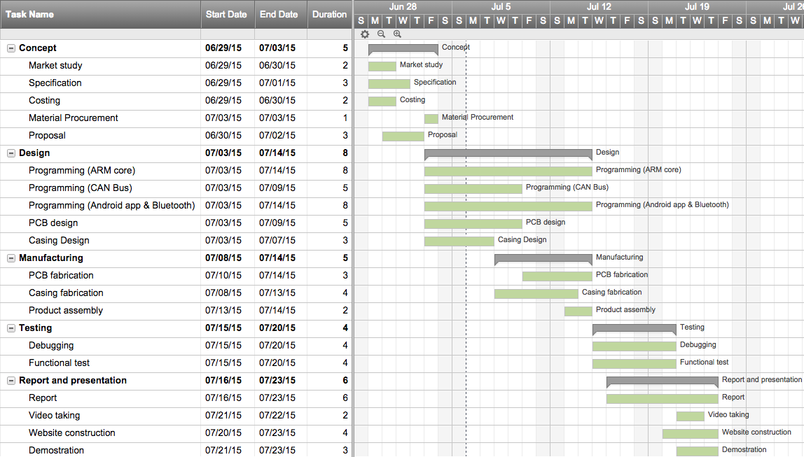

# Design Philosophy

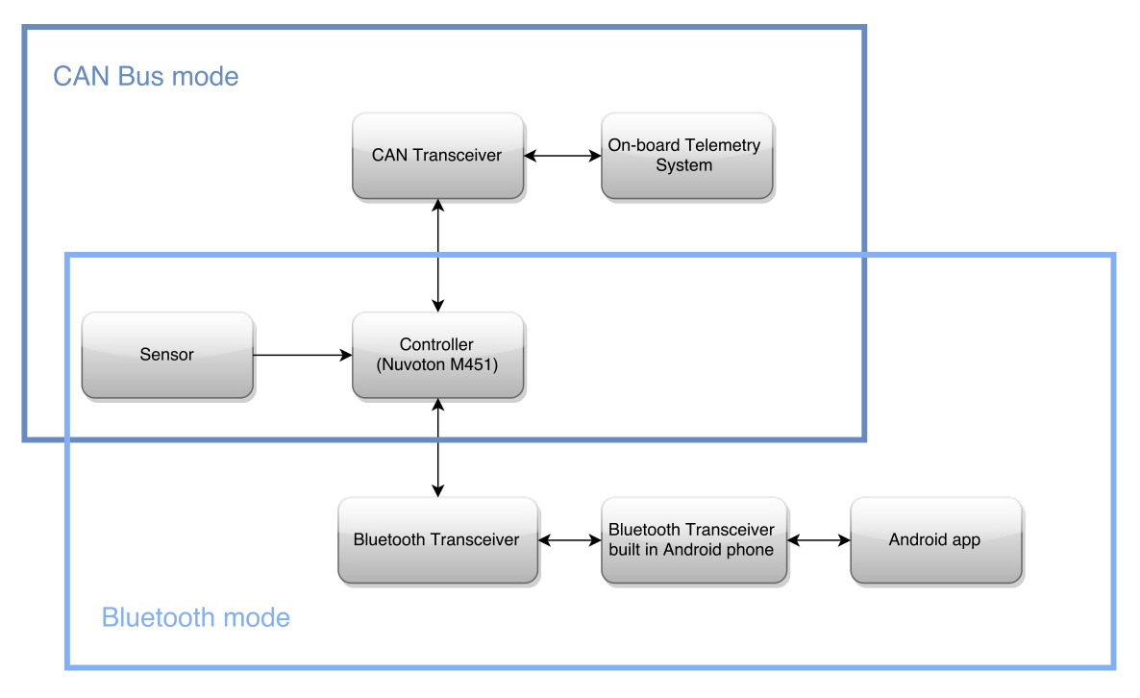

Our design have two operating modes, CAN Bus mode and Bluetooth mode.

In the CAN Bus mode, when the heartbeat sensor receive heartbeat pulses, it will transmit signal to the controller. When the controller receive the signal, it will convert the heartbeat data into heartbeat rate information. The information is then sent to the CAN transceiver. The CAN transceiver will then transmit the information to the on-board telemetry system through CAN bus.

On the other hand, the on-board telemetry system can also send reset command to the CAN transceiver through CAN bus. When the controller receives the signal through the CAN transceiver, it will read the data and reset itself if the data is a reset command.

In the Bluetooth mode, the sensor also transmits signal to the controller, but this time the controller will send the converted heartbeat information to the Bluetooth transceiver through UART port. The Bluetooth transceiver will then transmit the information to the Bluetooth transceiver built in an Android phone. The information can then be retrieved by the Android app and displayed on the app.

Similar to the CAN Bus mode, the Android app can also send reset command to the UART port of the controller through the two Bluetooth transceivers. The controller, after verifying the command, will reset itself.

## Hardware

The hardware component parts include the MCU, the heartbeat sensor, the bluetooth transceiver and the CAN transceiver. A main board PCB is used to connect all the component parts together and be responsible for the power supply.

**MCU**

The MCU we used is Nuvoton M453VG6AE, which belongs to the NuMicroTM M451 series. It is embedded with ARM® Cortex®-M4 core with DSP extensions and floating point unit and runs up to 72 MHz with 256Kbytes Flash program memory, 32 Kbytes SRAM, and 4 Kbytes Flash loader memory for In-System Programming (ISP). It is equipped with a variety of peripherals, and this time we will make use of the Timer, CAN, UART and GPIO functions.

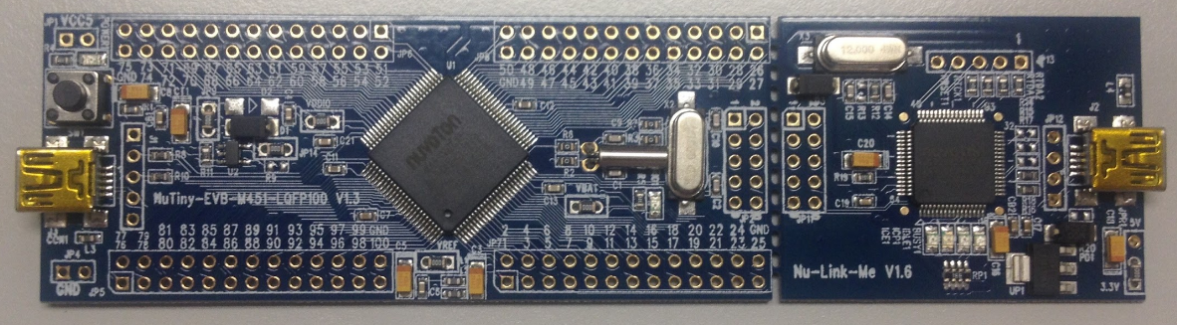

The evaluation board we used is NuTiny-SDK-M453. The NuTiny-SDK-M453 includes two parts: NuTiny-EVB-M453 and Nu-Link-Me. The NuTiny-EVB-M453 is the evaluation board and Nu-Link-Me is its Debug Adaptor.

Below is the M453VG6AE:

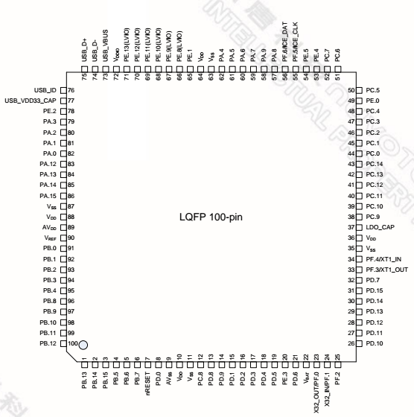

**Heartbeat Sensor**

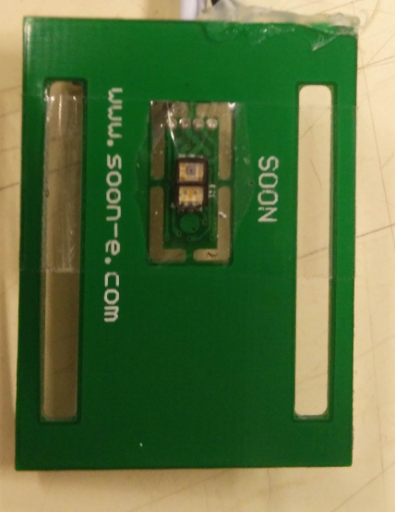The heartbeat sensor we used is SON1205, which is a heartbeat sensor module. It is based on SON1303, which is a pulse meter module for measuring heartbeat, and SON3130, which is the IC that process the signal output from SON1303. Every time when SON1205 is placed on a new place, before SON1205 can start to output the heartbeat pulse data, it needs 1 second for recognition and calibration.

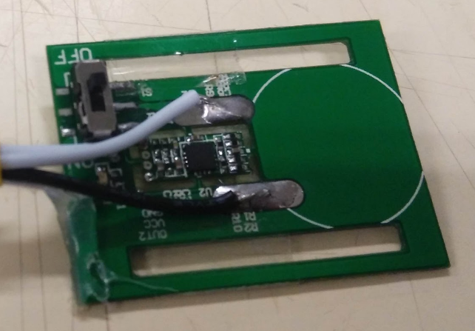

SON1205 has 4 pins, and the function of each pin is as follows:

|  |  |  |
| --- | --- | --- |
| Pin | Name | Function |
| 1 | VCC | Input pin (2.3 - 5V) |
| 2 | AO | Analog output |
| 3 | DO | Digital output |
| 4 | GND | Ground pin |

We decided to use the digital output instead of the analog output, because the focus of our product is not on the waveform of the heartbeat pulse, but the number of pulses. Therefore, digital output, which is only consist of “0”(i.e. 0V) and “1”(i.e. 3V), will be more suitable for our usage. The VCC pin will be connected to the 3.3V power supply and the GND pin will be connected to the ground of the main board.

Below is the schematics of SON1205:

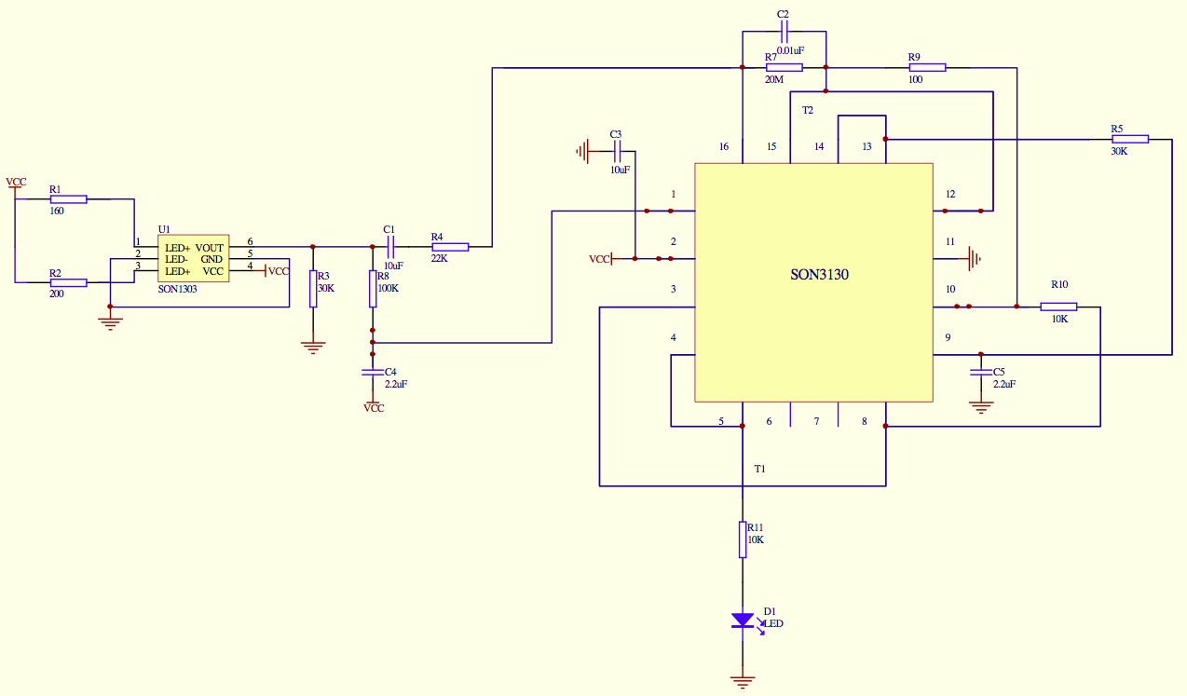

**Bluetooth Transceiver**

The bluetooth transceiver we used is HC-05. It is an embedded Bluetooth serial communication module, which can convert serial port to Bluetooth. Therefore, it can be used to replace the serial port wire, and allow two serial ports to communicate through Bluetooth. The default baud rate of HC-05 is 9600baud.

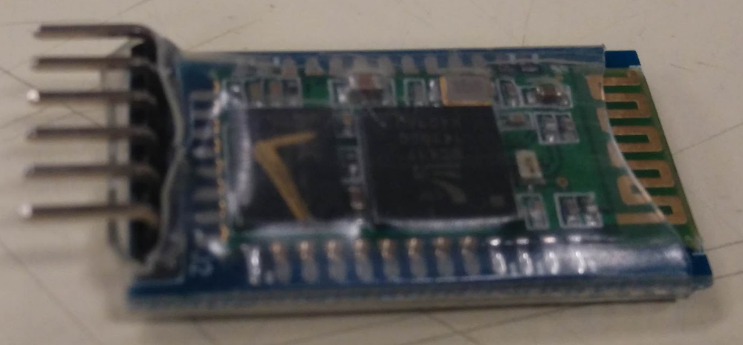

HC-05 has 6 pins, and the function of each is as below:

|  |  |  |
| --- | --- | --- |
| Pin | Name | Function |
| 1 | VCC | Input pin (4.5 - 6V) |
| 2 | GND | Ground pin |
| 3 | TXD | Transmit pin |
| 4 | RXD | Receive pin |
| 5 | KEY | Input high to enter AT mode. |
| 6 | LED | Output high when connected. Output low when not connected. |

In our design, only Pin 1 to Pin 4 are used, because we do not need to enter the AT mode. For the MCU to communicate with HC-05, we made use of the UART function. The receive pin of HC-05 will be connected to the UART transmit pin of the MCU, while the transmit pin of HC-05 will be connected to the UART receive pin of the MCU. The GND pin will be connected to the common ground of the main board and the VCC pin will be connected to the +5V power supply.

**CAN Transceiver**

The CAN transceiver we used is MCP2551. It is a high-speed CAN, fault-tolerant device that serves as the interface between a CAN protocol controller and the physical bus. It can convert the digital signals generated by a CAN controller to signals suitable for transmission over the bus cabling (differential output).

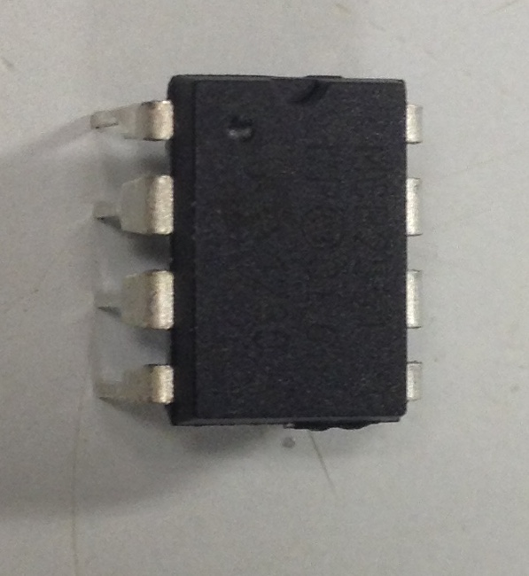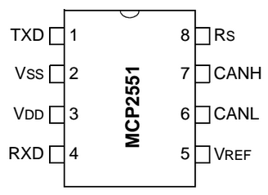

MCP2551 have 3 modes of operation, i.e. High Speed, Slope-Control and Standby. In our design, the Slope-Control mode is adopted because high speed transmission is not required and slope-control mode can obtain a better EMI performance. This is done by connecting an external resistor between the Rs pin and the ground.

The CANH and CANL pins will be connected to the corresponding pin of CAN Bus. The TXD pin will be connected to the CAN transmit pin of the MCU while the RXD pin will be connected to the CAN receive pin of the MCU. The VDD pin will be connected to the +5V power supply while the VSS pin will be connected to the common ground of the main board.

**Power Supply**

The input voltage of the main board is 12V, which is provided by the CAN Bus. However, all the components are not working at 12V, therefore we need to step down the 12V input to 5V and 3.3V. The 5V supply is for the MCU, the Bluetooth transceiver and the CAN transceiver, while the 3.3V is for the heartbeat sensor.

To do so, we chose to use the voltage regulator LD1117#33 and LD1117#50, which can change an input voltage equal or less than 15V to an output voltage of 3.3V and 5V respectively.

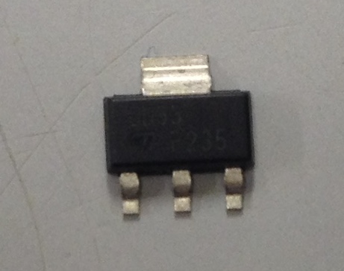 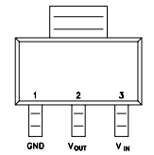

For the Vin and Vout pins of the regulator, two capacitors are added to each pin as filter so that stable power supply can be ensured. One of the capacitor is 100nF , which act as a filter for high frequency noise, while another is 10μF, which act as a filter for low frequency noise. The connection is shown as below:

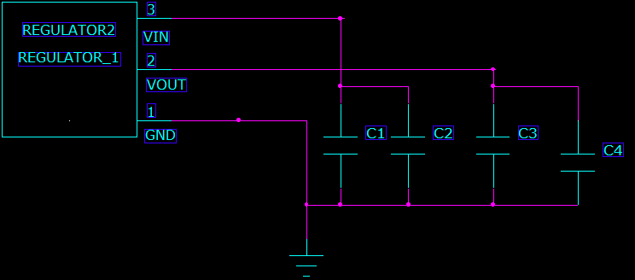

## Software

Software part is divided into MCU programming and Android app programming.

**MCU**

The MCU program is responsible for turning heartbeat pulses signal into heartbeat rate information and communicating with other peripherals through UART and CAN. The MCU is programmed with C language by using CooCox CoIDE.

To convert heartbeat pulses into heartbeat rate, we decided to count and record the number of pulses in each second, then we sum up the number of pulses in the last 60 seconds to form the heartbeat rate,i.e. number of heartbeat per minute. First, a timer interrupt with period of one second have to be set up, so that the interrupt handler can be called every second. We used Timer0 in our design. The interrupt handler of Timer0 will save the number of beats in the last 1 second into the array secondSum[60], and then start counting the number of beats for next second. Also, the handler will add up all the records of heartbeat in the last 60 seconds,i.e. all entries of secondSum[60], and then send the sum to UART or CAN. If it is in the first minute of measurement, the number of entries will be less than 60. In this case, MCU will try to estimate the heartbeat rate with the formula:

$$Heartbeat rate = \frac{\left(sum of all no.of heartbeat\right)× no.of entries}{60}$$

Since our measurement is done when the rider is moving and this can cause many errors in measurement, so we defined some rules to deal with the possible errors to improve the accuracy of our measurement. Below are two common situations that can lead to measurement error:

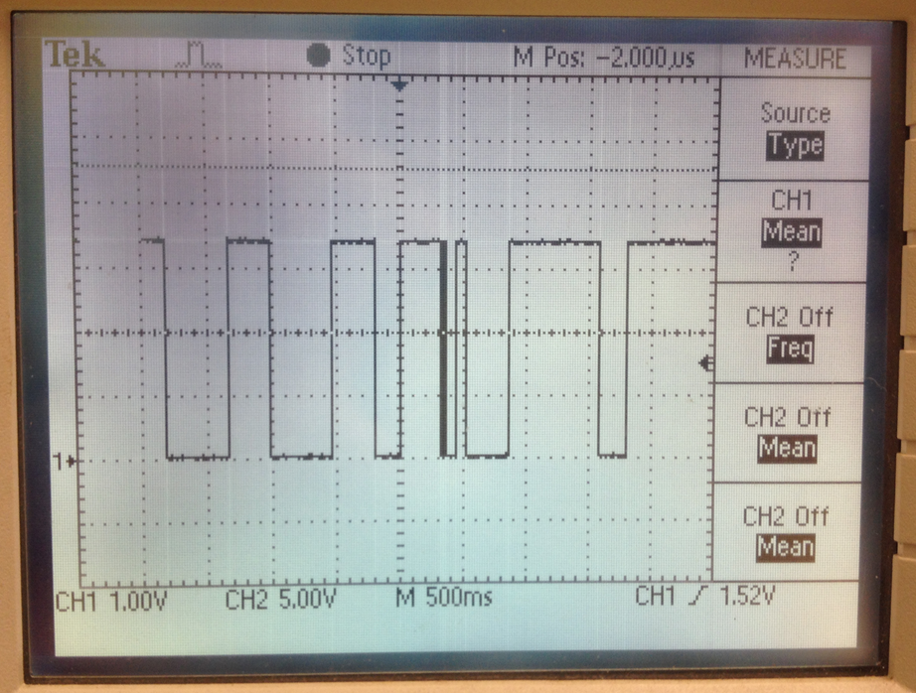 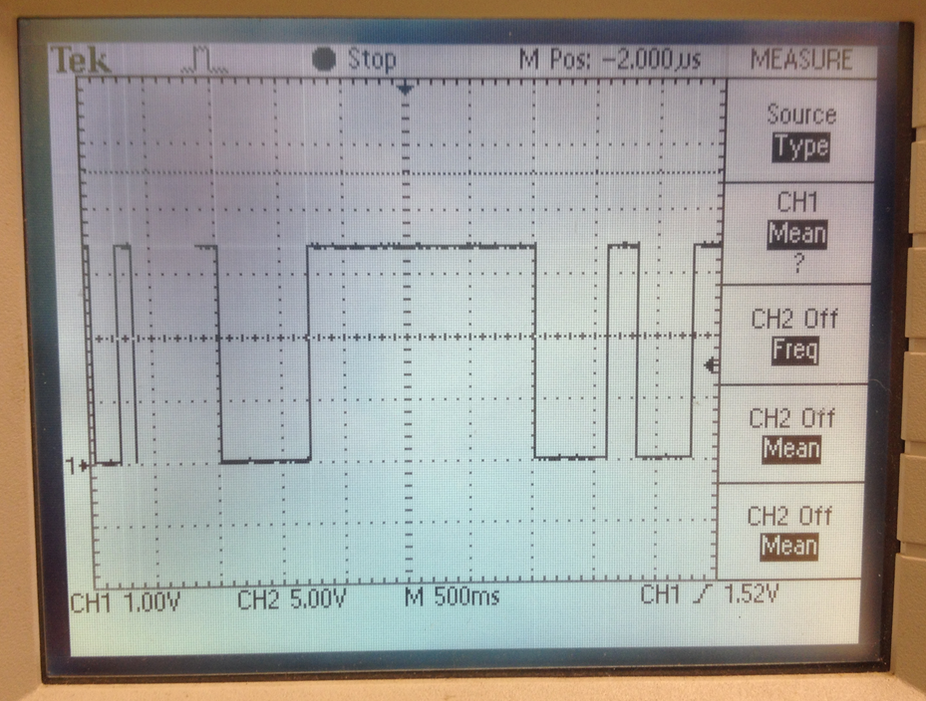

For the first type of error, the duration of “0” between consecutive “1” is too short. The heartbeat rate for a normal person should not be greater than 200bpm, that means the duration of “0” between consecutive “1” should not be smaller than 0.3 second. Therefore, we will neglect the “0” that has a duration less than 0.3 second, and it will be treated as “1” so that the 2 consecutive “1” will not be treated as 2 beats, as illustrated below:

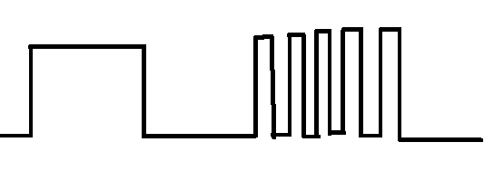 ➔ 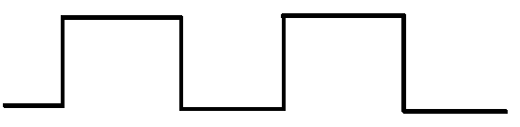

For the second type of error, the duration of “1” between consecutive “0” is too long. The heartbeat rate for a normal person should not be lower than 50bpm, that means the duration of “1” should not be greater than 1.2 second. When this error is encountered, the MCU will try to reset the board. If this situation continues,i.e. the MCU keep on reset, it should be due to a misposition of the sensor that making the sensor cannot function properly. In this case, the position of the sensor should be corrected.

On the other hand, the MCU need to communicate with UART and CAN peripherals. UART is used to communicate with the Bluetooth module. To transmit data using UART, we need to enable UART, open UART port and set the correct baud rate. Since the default baud rate of the Bluetooth module is 9600baud, the baud rate of the UART port is also set at 9600baud. To receive data from the Bluetooth module, the read interrupt has to be enabled. In the interrupt handler of the read interrupt, the data received will be verified. If the data received is a character “r”, then the MCU will reset itself.

CAN is used to communicate with the CAN system that connects the on-board telemetry system. Similarly, we also need to enable CAN, open CAN port and set the correct baud rate. This time, the baud rate is set to 500 kbps. Receive interrupt is also enabled for receiving command from the on-board telemetry system. When sending a CAN message, its frame type, ID type, ID, length of data and the actual data have to be specified. In our design, we set the frame type to be CAN_DATA_FRAME, the ID type to be CAN_STD_ID, the ID to be 0x7ff and the length of data to be 3(bytes). For the data content, the first byte of data(i.e.Data[0]) is the hundreds digit of the heartbeat rate, the second byte is the tens digit and the third byte is the ones digit.

When receiving a CAN message, in addition to enabling receive interrupt and setting up the handler, we still need to create a receive message object first. The ID type and ID has to be specified when creating the receive message object. In our design, we specified the ID type to be CAN_STD_ID and the ID to be 0xa. Therefore, when the on-board telemetry system send command to the MCU, it should configure the ID type as CAN_STD_ID and the ID as 0xa. When a message of this received, the interrupt handler will be called and verify the message. If the ID is 0xa, the MCU will reset itself.

When the MCU reset itself, it will clear all the variables and interrupts, and the Timer0 will be restarted.

**Android app**

The android app has to connect the Android phone to the Bluetooth module by Bluetooth, receive the heartbeat rate information from the Bluetooth module continuously, display the information and allow the user to reset MCU. This app is written with JavaScript and compiled by Cordova. The app is developed using the Ionic framework, which is AngularJS-based. Bluetooth function is added as a Cordova plugin, but since Cordova and AngularJS are not fully compatible, ngCordova is used as an extension of the plugin, so that the plugin can be used on the Ionic framework.

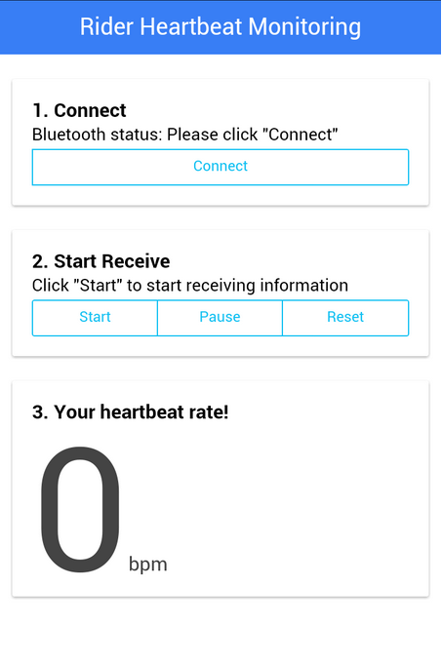

For the user interface, the design can be easily completed by using the css stylesheet provided by the Ionic framework. Adding object in the interface can be done by specifying the class a html tag. For example, when we added the card-like effect to the 3 sections, we specified the class of the <div> object to “card”, like this:

<div class="card">

         <div class="item item-text-wrap">

            <h2><b>1. Connect</b></h2>

           </div>

</div>

For the functions, we decided to have 4 buttons. One is for the user to start the Bluetooth connection between the Android phone and the Bluetooth module. The app will first check if the Bluetooth function of the phone has been enabled, if no, the app will tell the user. If yes, the app will try to connect the Bluetooth module. If fault happens, the app will tell the user that the Bluetooth cannot be connected, the user can then check the hardware connection to find out the fault cause. The second button is for the user to initialize the reception of heartbeat rate information. The third button is for the user to pause the reception of information. When the user press the “Start” button again, the reception can be resumed. The fourth button is for the user to reset the measurement and the MCU.

To implement the above functions, we can simply call the functions in the Bluetooth plugin library to accomplish. When the “Connect” button is pressed, the isEnabled() function will be called to check if the Bluetooth function is enabled on the phone. If not, the content of index.html will be changed to tell the result. If yes, the connect() function will be called to start the connection. When connect() is called, the MAC address of the Bluetooth device, i.e. the Bluetooth module, has to be specified. To get the MAC address, we can connect the module with the phone first and read the address on the phone. The content of index.html will be changed to tell the result. When the “Receive” button is pressed, the read buffer will be first cleared and then the interval and throttle functions will be called, with the interval set to be 1 second. Interval and throttle functions together can call a specific function with a specified interval continuously. In each second, the read() function will be called to read the received information and save it to the variable *data*. When the “Pause” button is pressed, the interval for the receive action will be cancelled. When the “Reset” button is pressed, a character “r” will be sent to the Bluetooth module by calling the write() function.

## Casing (Sensor)

Since movement of rider can affect the measurement accuracy a lot, we decided to hold the sensor on the riders’ back part of neck, as this part has the smallest movement when the rider is racing. To ensure the belt is held tight and the rider is comfortable, we chose the elastic fabric belt. To ensure that the sensor will not hurt the rider in case of accident, we do not fix the sensor onto the belt, but make a pocket for the sensor, so that it can easily come out in case of accident.

# Manufacturing Process

During the PCB manufacturing, the first step was the PCB design. PADS Logic was used for drawing the schematic diagram. When drawing the schematic diagram, some components are drawn specific in a newly created library for this project, eg: MCU and sensor and so on. And then, PADS Layout was used for handling the decal of the new components. After all connections were verified, a layout file was exported to PADS Layout for routing propose.

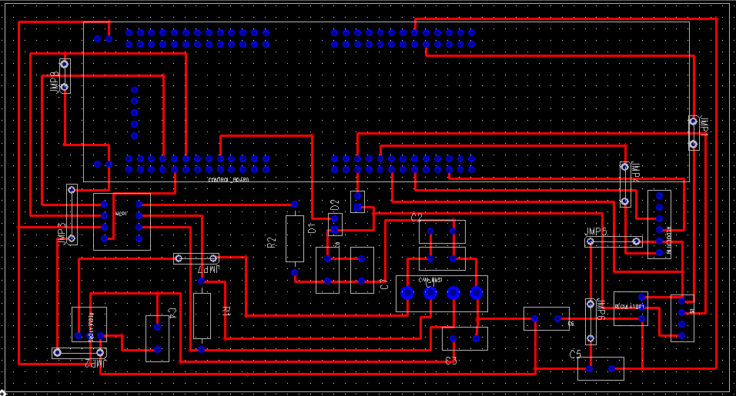

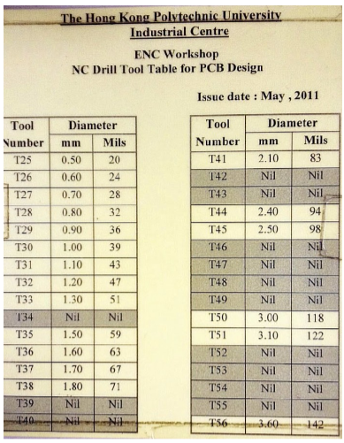

After the routing was finished, all pads and hole size were corrected to correct size for drilling. Then a drilling file was exported by using the CAM function in PADS Layout for the auto drilling machines. The drilling file is needed to be updated according to below table as the properties of the auto drilling machines.

After the drilling on the board, the board will be undergone a chain of PCB manufacturing process which includes exposure on the dry film, etching….etc.

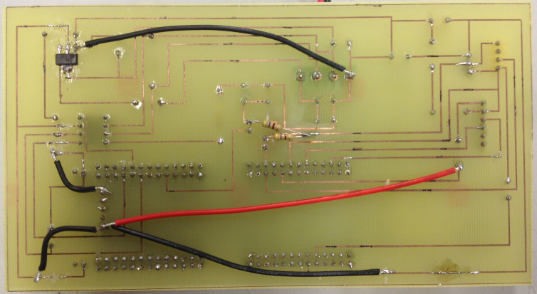

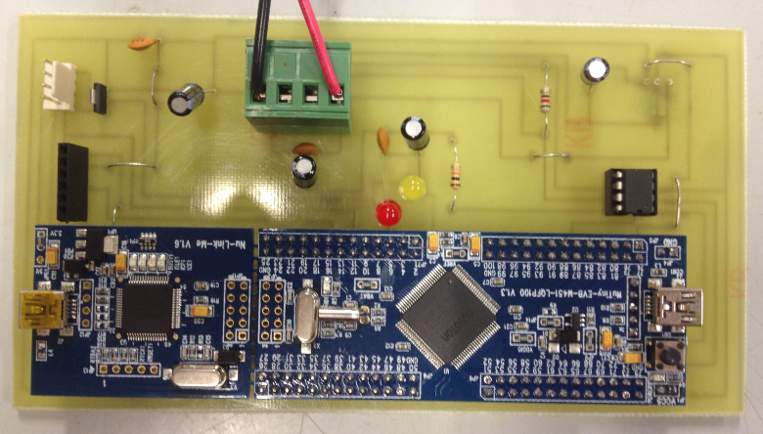

After all components are soldered on the PCB board, some hardware and software testing are performed.

# Testing Methodology

## Hardware

First of all, we have to inspect the PCB to confirm that no path is broken and no unwanted shorted path. This can be done with the help of multimeter and the magnifier.

Then, when all the components have soldered to the PCB, we can provide a 12V input to the board without the peripherals, which include the MCU, the sensor, the Bluetooth module and the CAN transceiver. This action is to ensure that all the power supply to the peripherals is working correctly, because the peripherals can be destroyed with incorrect input voltage. We tested this by using a multimeter to test the voltage at the points that provide power to the peripherals.

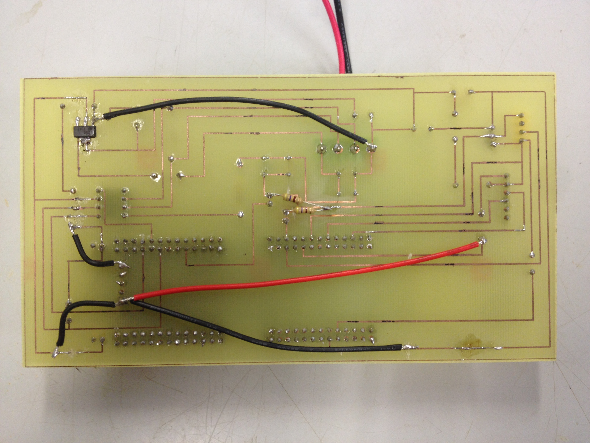

Lastly, we can plug in all the peripherals and test the board with program. In this stage, we have to check if all the peripherals can work properly and all LED can function as programmed.

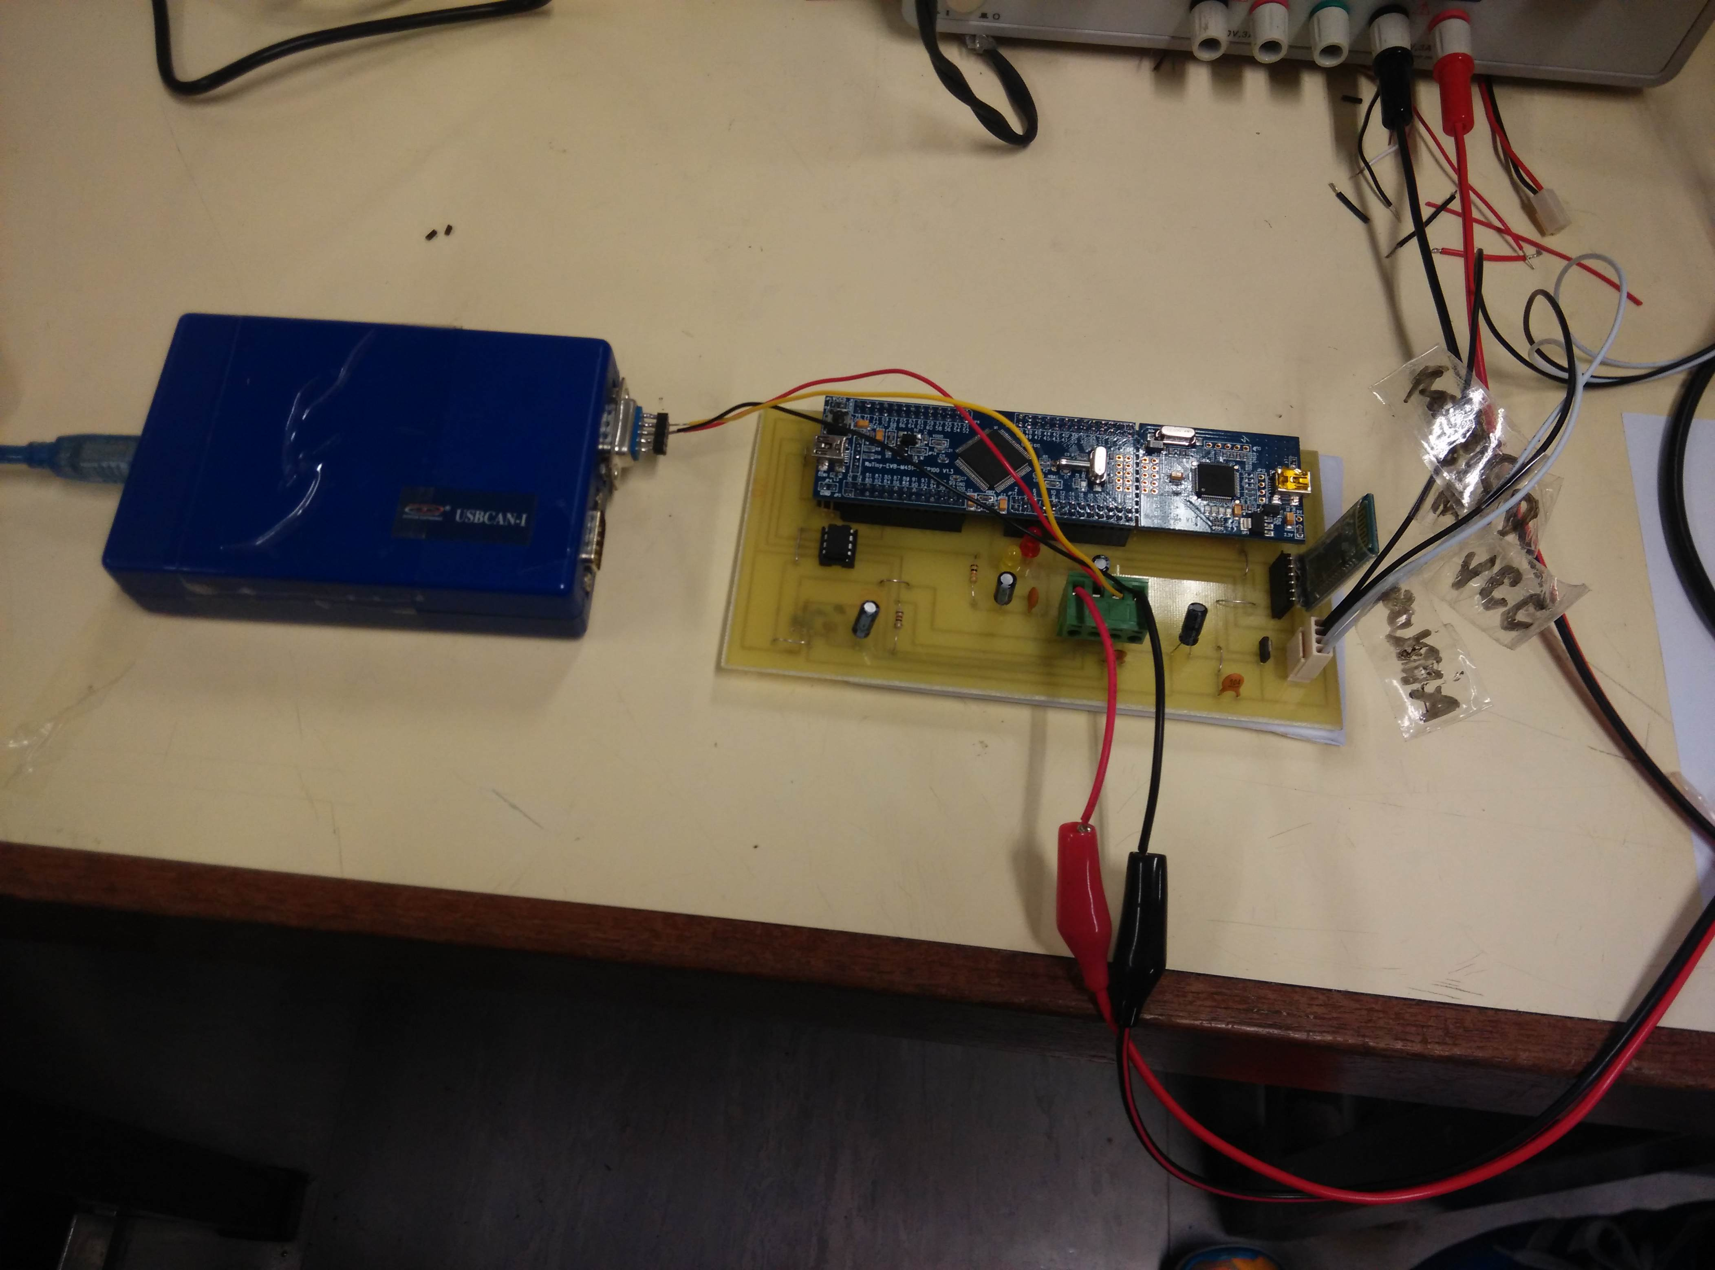

## Software

To test the program, we mainly made use of the education board of M451 series MCU and breadboard. The heartbeat rate information is displayed on the screen. We also made use of a CRO to confirm that the counting of heartbeat by the MCU is accurate and to verify the response of MCU towards the error.

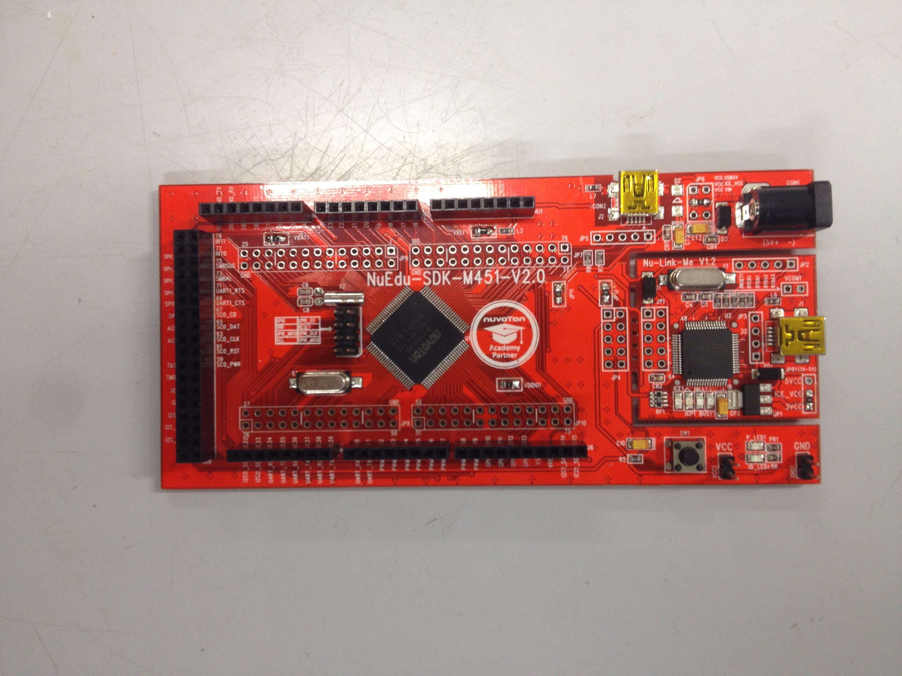

To test the CAN function, we made use of the CAN analyzer and the CANTest software. We used the listener mode to test the transmission part and used the normal mode to test the reception part by controlling a LED.

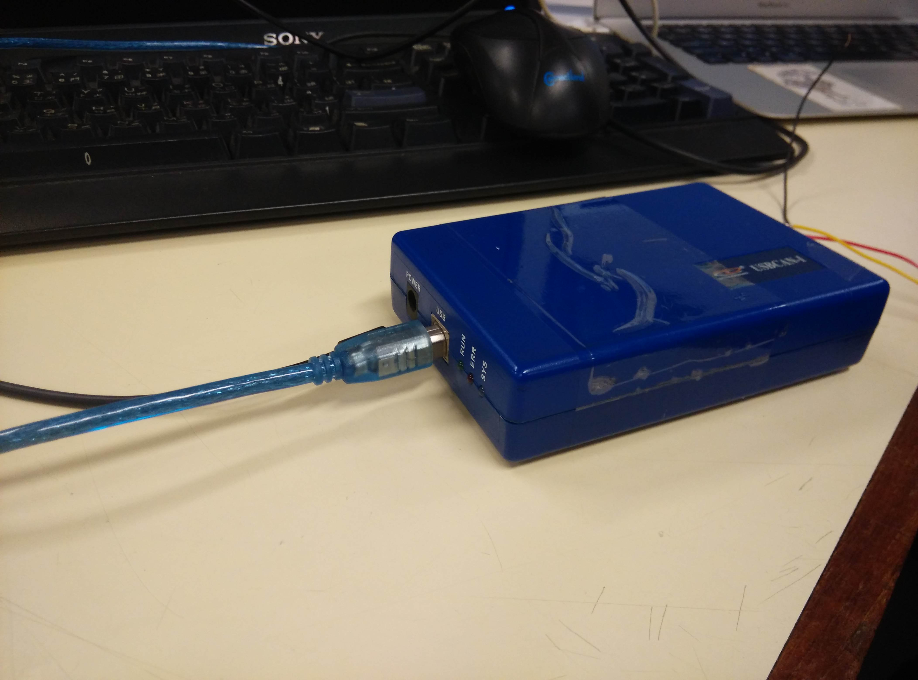

To test the UART function, we made use of the RS232 serial port and a PC terminal software called Tera Term. We tested the transmit part by reading the result of the terminal, and tested the receive part by controlling a LED.

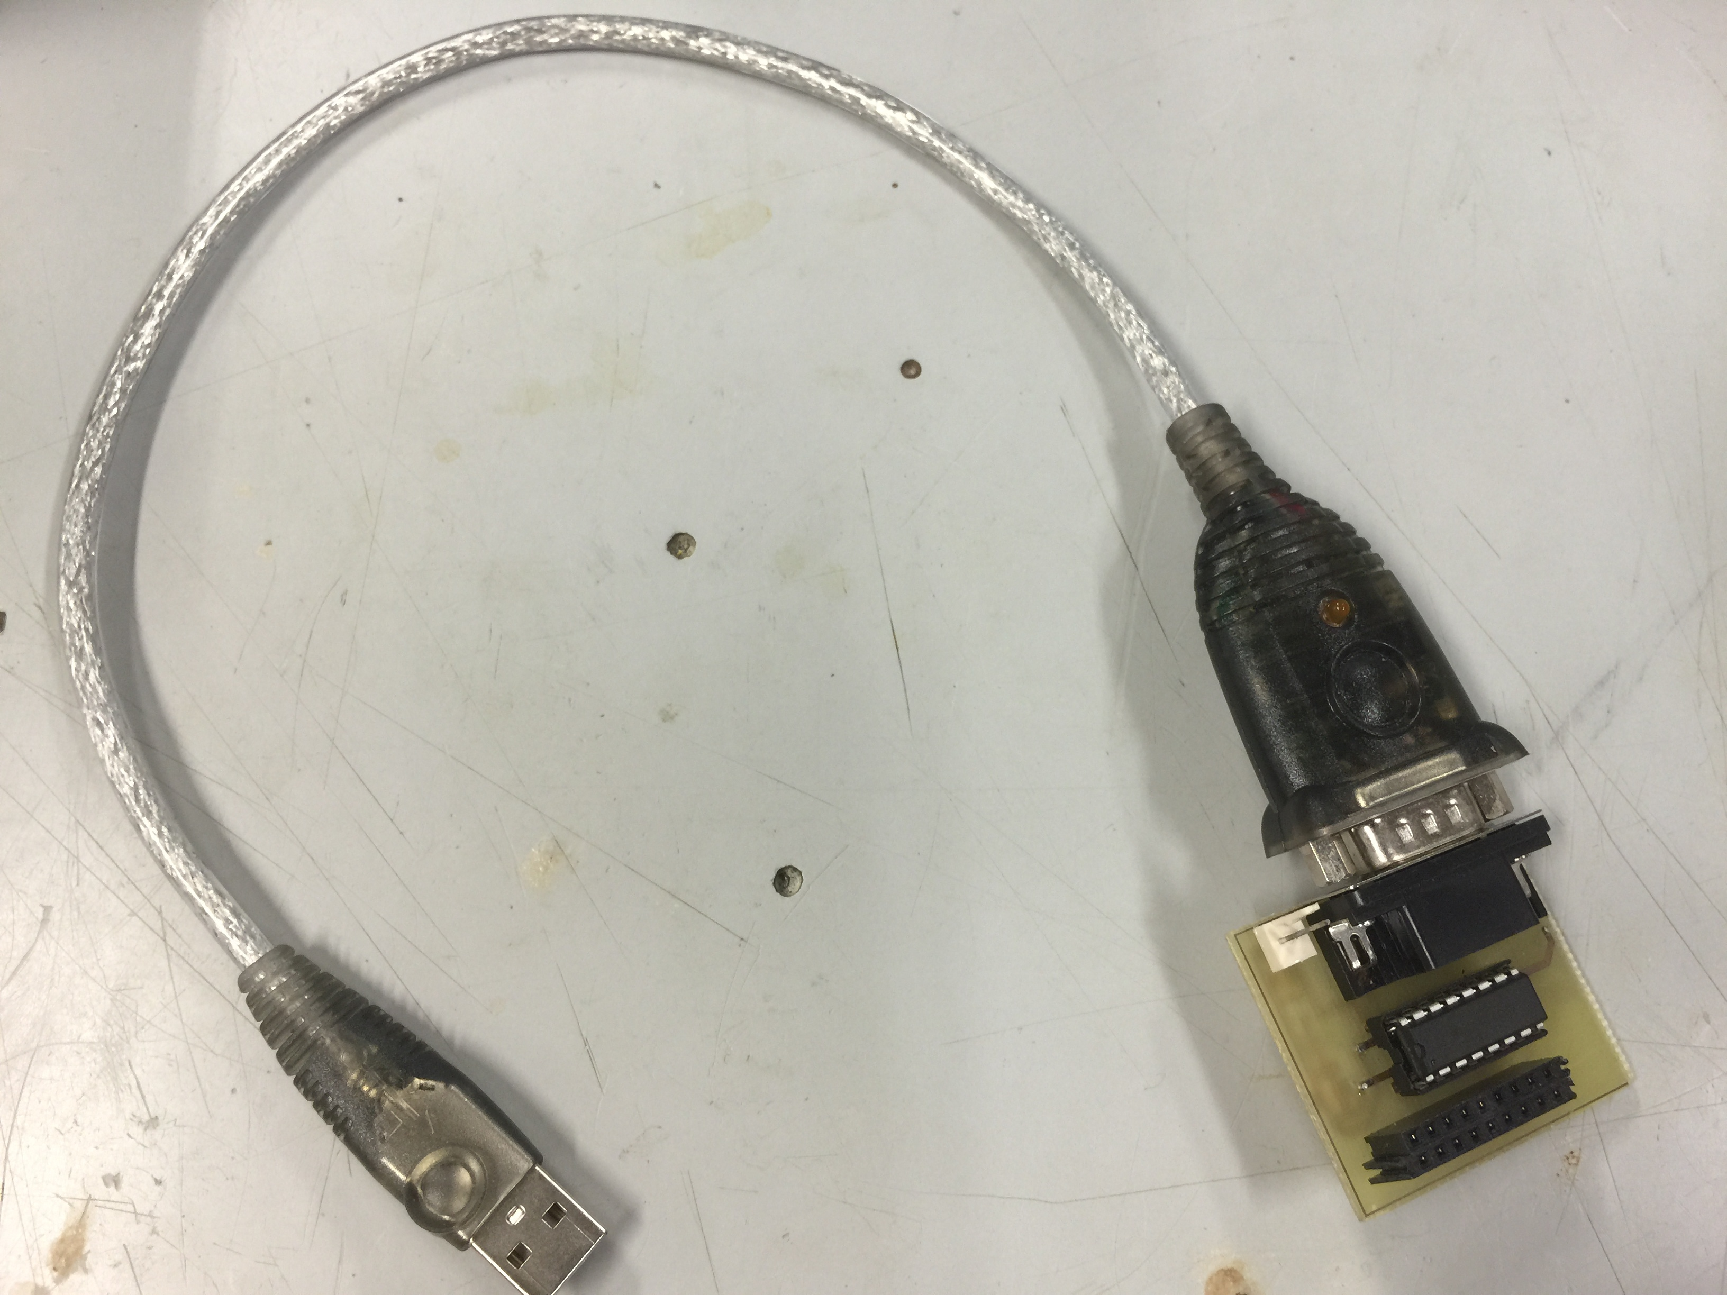

To test the Bluetooth function, we replaced the RS232 serial port with our Bluetooth module and an Android phone with terminal app. The test is the same as testing UART function.

To test the Bluetooth function of Android app, we connect the Bluetooth module to the RS232 serial port and use the terminal software on PC to verify the transmission and reception functions.

## Casing and Functional

We connect all the parts and tried to simulate the situation on a racing pedal car. We put the sensor with casing onto the tester and let the tester sit on a chair as if he is on a pedal car. The tester tried to move as if he is riding the car to check if the casing and the measurement function is working as we designed.

# Product Evaluation

**Accuracy**

To evaluate the accuracy of the heartbeat rate measurement, we tried to compare its data with that from professional heartbeat rate meter. We chose Apple Watch for comparison use because it is relatively easier to access due to its popularity. Also, the heartbeat sensor we use adopt the same measurement theory as Apple Watch, i.e. using green LED lights paired with light-sensitive photodiodes to detect the amount of blood flowing under the skin and using the difference in the amount of blood to determine a beat.

As Apple Watch is held on the wrist and our heartbeat sensor is held at the neck, the measurement of two devices can be taken at the same time. Below are some data of our heartbeat rate measurement system and of Apple Watch:

|  |  |  |  |  |
| --- | --- | --- | --- | --- |
|  | Trial 1 | | Trial 2 | |
|  | Our system | Apple Watch | Our system | Apple Watch |
| At rest | 61 bpm | 62 bpm | 60 bpm | 63 bpm |
| Riding | 44 bpm | 59 bpm | 42 bpm | 60 bpm |

We can see that our system has a similar result as the Apple Watch at rest. However, when we try to simulate the movement of a racing rider, the result of our system drops a lot while the result of Apple Watch drops only a little. The difference between two devices’ results also becomes larger. From this we can know that movement can interrupt the result of the measurement, and this is also admitted by Apple on the webpage of Apple Watch. However, our device is more vulnerable towards the affect from movement than Apple Watch.

The above difference may be due to the following reasons. First, Apple Watch uses two pairs of green LED and light-sensitive photodiodes, while our sensor only uses one pair. Two pairs of LED and photodiodes can help to refine the measurement results because when one pair has detection error, another pair can lower the influence caused by the error. Second, Apple Watch may have adopted different and better policies when movement error is detected. Third, despite heartbeat sensor, other sensors such as accelerator is also included in Apple Watch, and the data gathered by these sensors may also be used to refine the measurement result.

To conclude, our heartbeat rate measuring device is still far from perfect for usage during race but it can provide a rough measurement for reference.

**Reliability**

When any electronic device work for a long period, its temperature always increases and temperature rise can cause instability to the device. Therefore, we tried to let the system operate for a long time, say 10 minutes, to test its reliability.

When we tried it for the first time, the MCU reset itself automatically after around 2 minutes. After its first reset, it kept on reset for several times, and the interval between each reset became shorter. We suspected that the problem may come from temperature rise because reset only happened after a period of time. Then we discovered that the 12V to 5V regulator is abnormally hot. As suggested by the mentor, we connect the GND pin of the regulator directly to the CAN Bus GND, so that the heat can dispersed more quickly.

We tried it for the second time, the MCU still reset automatically after around 5 minutes. However, as the period before reset has lengthened, we knew that we were on the right track. This time we tried to connect the the Vout pin of the regulator to a piece of copper sheet(wrapped with paper to avoid short-circuit) so that the excessive heat can be dispersed to the copper sheet. We tried the third time, and this time the MCU still did not reset after 10 minutes.

The overheat problem of regulator may be due to an imperfect routing, e.g. the width of certain paths is not great enough for heat dispersion.

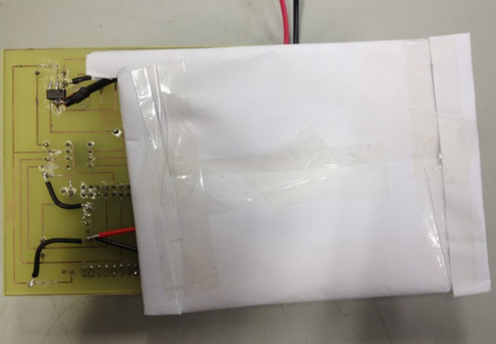

# Conclusion

At the end of this project, we can successfully build a working system for monitoring the heartbeat rate of riders in the pedal car race. This system include a wearable device that equipped with heartbeat sensor, a controller main board that can be fixed on the pedal car, and an Android app that can monitor the heartbeat rate. Signals of heartbeat can be detected and converted to heartbeat rate, and the information can be delivered to Bluetooth devices and CAN system.

In addition to the physical achivement mentioned above, we have also gained a lot of precious knowledge and experience during the project. We learnt about the product development cycle, i.e. from planning and research, to hardware and software design, to PCB fabrication and software programming, and finally to debugging and reporting. We experienced the whole cycle and learnt many things in each part of the cycle. For example, we learnt to design our own circuit, and realising it by drawing schematics, routing and PCB fabrication. This is what we can hardly get in touch in normal training. Besides, we also learnt a lot in programming, especially in Android app, because this time we used a quite new development method to write the app, which is using the javascript. The knowledge and experience we gained has made us more confident in future projects, no matter it is academic or job-related.

Finally, we would like to thank our supervisor and mentor for giving us very useful suggestion and solution when we encountered problems. We knew little and we did not have much experience, so their advice was very crucial to our project.

# Recommendation

We have finished the basic requirement of the project. The heartbeat pulses detected by the sensor can be transmitted to the MCU, converted to heartbeat rate information and then delivered to the Android app through Bluetooth and to the on-board telemetry system through CAN. However, as stated in the Product Evaluation, the accuracy and stability of the device still needs improvement. Therefore, for future development, we suggest to improve the accuracy and the stability of the device first.

To improve the accuracy, double sensors and better algorithm can be employed. The output of SON1205 is actually quite accurate, because its result is similar to that of Apple Watch when at rest. Therefore, we do not think that the heartbeat meter SON1303 should be changed, instead, two SON1303 can be used to refine the result when the rider is moving. This means that custom module with SON1303 and SON3130 can be designed to replace SON1205. Besides, better algorithm can be developed to deal with the movement error.

To improve the stability, more effort should be put into the routing of PCB. Be careful about the path width to ensure it is wide enough for the heat to disperse. Attention should be especially put on the path connecting common ground and the path connecting the regulator input and output, because normally a greater current, and hence more heat, can be found at these paths.

Besides improvement, additional function is also suggested. For example, adding a constantly updating graph in the Android app to show the change of heartbeat rate within a period of time. Therefore, the health condition of the rider can be assessed graphically.

# References

1. Learn how Apple Watch measures your heart rate, and get tips for a more accurate reading.

<https://support.apple.com/en-us/HT204666>

2. Target Heart Rates

<http://www.heart.org/HEARTORG/GettingHealthy/PhysicalActivity/FitnessBasics/Target-Heart-Rates_UCM_434341_Article.jsp>

3. Resting Heart Rate Table

<http://www.topendsports.com/testing/heart-rate-resting-chart.htm>

4. Reference for market research

<http://www.wareable.com/fitness-trackers/best-heart-rate-monitor-and-watches>

<http://www.amazon.com/Suunto-Basic-Heart-Rate-Belt/dp/B0106O4RCG>

<http://www.suunto.com/Products/Heart-Rate-Belts/Suunto-Basic-Heart-Rate-Belt/>

# Individual Report for Each Member

Project Name: Rider’s Health Condition Monitoring System  
Project Code: 15N05  
Student Name: Luk Quentin  
Student ID: 12061729D  
  
**Introduction**  
The product that we made in this innovative project was called “Rider’s Health Condition Monitoring System”. In this project, we were required to make the device which can let the station observe the health condition of the riders in a 24hours pedal car race. After discussion, we chose to measure the heartbeat for reference as it is more convenient to record in comparison with other factors (e.g. blood pressure, breathe rate). Thus, we used a heartbeat sensor to measure the heartbeat, then used a controller board to transmit the heartbeat into heartbeat rate signal. The rate signal were decided to transfer into two ways: (1) an Android application via Bluetooth and (2) the station via CAN Bus. In this project, we have to apply the knowledge of programming, PCB board design, PCB board fabrication as well as the design of the device (how to locate the sensor on the rider without causing any uncomfortable issue?). This project is practical as it needs to be easily applied in the future pedal car race.  
  
**Project Role and contribution**  
In this project, I am mainly responsible for two parts, which are the PCB board fabrication, the casing as well as the design of the product.   
For the PCB board fabrication, we need to revise how to make a PCB board by a piece of cooper and the film of a designed layout. In the process, some basic techniques such as DC drilling and etching were used. As it is a practical project, the board needs to be accurate with no errors and we have to manufacture more than one board for finding the best one to do further testing and demonstration.   
For the design of the product, as we try to imagine if the device really needs to be applied in the real situation, there are some factors that become essential such as safety issues and trying to be comfortable and user-friendly. So, not only the software and hardware part, we were also focus on the design on it.  
  
**Problems and solutions**  
  
During the process of the project, I found quite a lot of problems in it but finally we came out solutions to tackle each problems. The problems are shown below:  
  
1) For the sensitivity of the sensor, at the beginning we found that it is hard to record a stable heartbeat so we made two decisions, which are purchasing another sensor as well as finding a suitable place to locate the sensor while the rider is in the position of riding the pedal car. At last, we decided to locate it at the back of the rider’s neck as this part involve less movement while the rider is shaking their feet and hands to control the car.   
  
2) For the comfy issue, if the device makes the rider uncomfortable, it will probably affect the performance of the riders or even worse, the safety will become worse. Hence, we used a soft, elastic belt for holding the sensor on the neck, and what is more, the sensor is put inside the belt so the rider may not feel something hard and make them uncomfortable.   
  
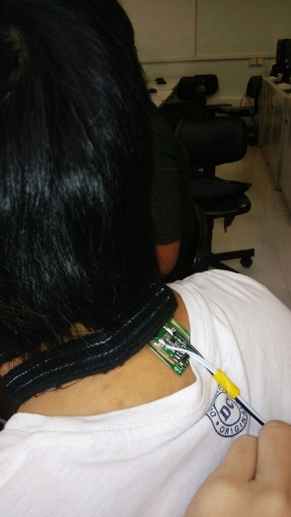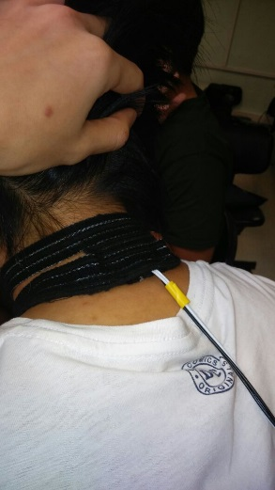3) For the safety issue, as the device hangs on the neck, accidents may easily happen if the device cannot be removed easily. Therefore, we used the Velcro for holding the belt. Also, the sensor and the belt are separated so when accidents happen, the sensor will easily take off the belt for avoiding the neck injury for the riders.

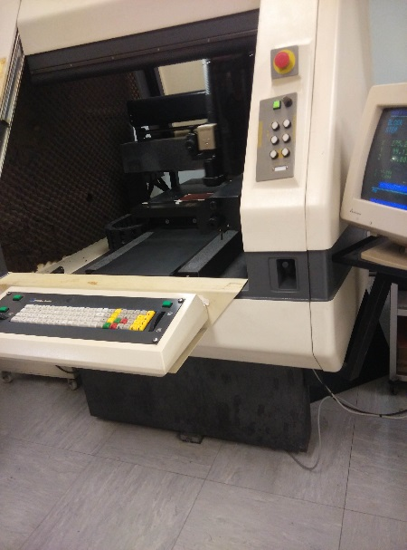  
4) For the fabrication of PCB board, human errors will be occasionally made so we have to manufacture a number of PCB boards for a better result. Also, learning from the workshop assistants from IC Centre, we learnt quite a lot of tips when we were making the PCB boards. Also, it is better for us to test whether the circuit of the board is clear and good by using some tools like multi-meter and light platform.   
(E.g. using the digital drilling machine to increase accuracy rather than manually controlled drilling machine.)   
  
  
**Conclusion**  
The one month project gave me an introduction in how to make a practical device in an efficient way. I think it is a good experience for me to have a touch in not only software but also hardware development. I think I could involve more in the software part other than fabrication and practical design. I will be glad to have more and more chance to do development, letting me explore different part to strengthen my knowledge.

Individual report

Group No. 15N05

Student Name: CHEUNG Ho Yin

Student ID: 12059114D

**Introduction:**

The project objective is to monitor the health condition of the pedal car rider to make corresponding substitution during the pedal car races. Heartbeat rate is used as reference in our project as it is the most effective way. One heartbeat sensor is used to detect the heartbeat pulse of the rider and deliver the pulse signal to controller. And then the controller will sent the signal to our android application via Bluetooth and on-board telemetry system via can bus so that the team assistants in the station to determine the timing for substitutions.

**Technical Content**

In this project, I concentrated in the PCB design. First of all, once some testing were performed, a draft PCB layout was proposed. And then, I was starting to draw the schematic diagram and create a new library for this project by using PADS Logic.

First, we also drew some new components for this project as it will be more efficient for further use and more suitable for our project. To produce a new component, I not only draw the CAE decal which is a decal shown in PADS Logic but also the PCB decal of the components which is a decal shown PADS Layout. After I drew the CAE decal in PADS Logic, I opened PADS Layout to draw the PCB decals. As those components were not in the PADS library, we need to measure the actual size of the components in order to allow the actual components inserted in to our PCB. So, we need to measure all components precisely. After the PCB decal of components were finished, we can start to check the PCB decal carefully.

The schematic diagram was checked carefully after it had been finished as it affect the routing process and even the application of this board. After the verification, a pcb file is created in PADS Layout according to the schematic diagram drawn in PADS Logic. In routing process, I am striving for the tidy and compact routing for the PCB in order to create a smaller but capable PCB. As there are 19 components, it is hard to draw a routing in order and without any cross. So, some jumpers are used in routing. After the routing is finished, we checked the pad size of all components. For example, the pin of can bus is bigger than the others, so we need to enlarge the pad size and the hole in order to make it fit the can bus pin and insert in properly. After that, we checked the routing and the schematic again as it is very important and cannot bear any mistakes because our time is very tight.

Once we are sure that the schematic and layout were confirmed, we export the drill file by CAM. The drill file is need to be amended as out auto drilling machine is not compatible to PADS exported file. We save it into floppy disk for the machine use. Moreover, we exported it to a pdf for dry film process. And then, we passed these documents to manufacturing teammates.

Second, we also face some difficulties although the board is created, as the routing connection line is not drawn thick enough, there are some cooling problem for the regulators, so the regulators works sometime only. This is quite impressive as it is not a functional problem but performance problem. As we do not have sufficient time to create a new board, our temporary solution is connecting the regulators to a big copper board for cooling process.

**Conclusion**

This is an innovative project to us as we are first time to handle an industrial project that is combining hardware and software and what I learnt in the past years.

My practical skill is well developed as we can manufacture a usable kit for pedal car rider. We cannot only concentrate on the performance of the device but the safety, the comfort of the user, the cost of the product and the chasing the progress of the product development within limited time and resources. This is quite practical and impressive to me as to finish and get the job done faultlessly is not an easy task.

Next, I learnt how to solve the problem also. During the PCB testing, we found that the connection wire we drawn is not thick enough. So there is a cooling problem in regulator. Our product performance is not well sometimes when the regulator is over heated. So we need to find a way to cool it down other than creating a new board as we did not have enough time. Our way to solve this problem is to connect the regulator to a copper board so that those heat can be transferred to the copper and finally the regulator is cooled and function and perform well. This is a good example of the problem solving during our project.

As this is a big project, those workload are divided into different parts and share them among us. So the communication between us is important as a team. Although the workload is shared, the project is integrated and produce a functional product. This is amazing.

And finally thanks for all teammates work well and closely so that our project can be finished on time and well.

Individual report

Group no: 15N05

Student name: Lai Tsz Shan

Student ID: 12058276D

**Introduction**

My group is responsible for the Rider Health Monitoring System, which can be used in the pedal car competition. The requirement of the project is to measure the heartbeat rate of the racing rider constantly, and display the information on an Android app, or transmit the information to the on-board telemetry system. The system is divided into 5 parts: the heartbeat sensor, the MCU, the Bluetooth module, the CAN transceiver and the Android app. The job is mainly divided into 3 parts: MCU programming, PCB design and fabrication and casing design and fabrication.

**Project Role**

I am responsible for the programming of MCU, including converting heartbeat pulses into heartbeat rate information and communicating with the on-board telemetry system through CAN Bus, but not including communicating with Bluetooth.

**Contribution**

My main focus is on how to convert the heartbeat pulses data into useful information of heartbeat rate. The main idea to accomplish this task is to record the number of pulses in each second, and then the heartbeat rate can be calculated by adding up the records of the last 60 seconds.

Before converting the data, we have to first receive the data. The digital output waveform was first investigated using the CRO. It consists of “1” and “0” data, where 3V represents the “1” and the ground represents the “0”. “1” means a heartbeat, that is when the blood pumped, while “0” means the period between two consecutive beats. Then the sensor can be connected to the MCU, with 3.3V power supply. The pin that is connecting to the digital output of the sensor has to be set as GPIO input first, then the data output from the sensor can be read by the MCU.

After that, we can start to count the number of heartbeat. When we count one beat, we have to first determine if it is a valid heartbeat. Again, the waveform of the digital output is investigated with CRO, but this time the sensor will be put on a moving wrist to simulate movement of the rider. There were mainly 2 types of errors, duration of “0” being too short and duration of “1” being too long, which can be seen in following diagrams:



For first type of error, the “0” will be neglected. For second type of error, the MCU will reset. To make these rules into the program, the negative-edge trigger is adopted when counting beats, i.e. one beat is counted when the signal change from “1” to “0”. When one beat is counted, the variable *counted* will be toggled. To know the duration of “1” and “0”, the variable *ON_time* and *OFF_time* is defined, and they will keep on increase with each increase equal to 0.00000042s. When “0” change to “1” or “1” change to “0”, the OFF_time or ON_time is cleared respectively.

Then we can decide if the beat is valid by knowing the ON_time and OFF_time.

Finally, we can start recording the number of heartbeats and calculating the heartbeat rate. A timer with interrupt interval of 1s is set up. The interrupt handler is responsible for saving the number of beats counted after the last interrupt. Records of last 60 second will be saved into the array *secondSum[60].* Therefore, when we use a for-loop to sum up all data in the array, we can obtain the heartbeat rate. If there is less than 60 record, we will use a simple ratio to estimate the heartbeat rate.

**Problems and Solutions**

One of the problem I encountered is when declaring the ON_time and OFF_time. At first, I did not know the reading frequency of the pin so I declared them using the variable type uint8_t, which means a 8 bit unsigned integer, because all of the other variables uses this variable type. However, the program did not work as expected. At that time, I tried to compare the value of ON_time and OFF_time with the CRO capture, so that I can know the time interval between each increase in value. However, the values and the CRO capture were not consistent. When a “1” was longer on the CRO, the corresponding ON_time was not longer. And I could see that there were a few value is 255, which is the maximum of uint8_t. Therefore, I thought the problem may be come from incorrect variable type, so that the value exceed the maximum of the variable type. Then I tried using uint16_t and uint32_t, and I got the expected result when using uint32_t. I also calculated by ratio that the reading frequency is around 2.38MHz(=1/0.00000042).

**Conclusion**

This project consolidated our knowledge in both hardware and software programming by giving us an opportunity to have a hands-on practice of what we have learnt. Besides, we also learnt some new knowledges and gained great experience which can equip us with a stronger sense in the area of electronic and information engineering. We have the chance to get in touch with the mos updated technology in the project, and this can help our learning and increase our competitiveness.

Moreover, we can learn how to design a product in the project. We need to do a lot of consideration and evalution before we actually design the product. And we need to do a lot of study and research before we can finally complete our product. Despite the hardware and software knowledg, this project has also given us a chance to practise our reporting skills.

Most importantly, it gave us a chance to learn to cooperate with different people, and to let everyone to be involved even if they are not very familiar with the technology. For people who are not quite familiar with the topic, they can try to help in reading datasheets, doing reserch and reporting.

Individual report

Group no: 15N05

Student name: So Ying Pong

Student ID: 12061858d

**Introduction**

The topic of our project is Rider Health Monitoring System, that is used in pedal car competition for checking the health condition of a pedal car rider. The heartbeat rate of a rider is measured by a sensor. It is then processed to useful information by the program in the controller. There are two modes, the heartbeat rate of the rider is either sent to the on-board telemetry system by CAN bus or an android application by bluetooth.

**Project Role**

My role in the project is PCB making and the design of the belt. After deciding the circuit, the PCB is made by fabrication, soldering of components and some finishing work.

Another part of my work is the design of belt. The sensor is fixed on the neck a pedal car rider with a belt and velcro. The safety, comfort of the user and the fasion design of the device the

**Technical part**

After deciding the circuit layout, the PCB board is drawn by PADS layout. It then goes through the PCB fabrication process. The circuit is printed on the copper board. The first step is drilling of the board. A file that stored the information of drill holes is saved in a floppy disk.It is then drilled with the machine. Then the surface of the copper board is polished with sandpaper.

The next step is the dry film process. A dry film is placed on the polished copper board. The plastic cover layer is removed and dry film is placed on the board. Then is the lamination process. The board with the dry film passes through a heater with 250 C to fix the dry film on the board.  
After that, place the circuit film on the copper board and exposure  it under UV light for 10 minutes. The circuit will be printed on the copper board.

The next step is to remove the upper plastic layer on the dry film. It is then soaked in the developing tank. This process is to remove the unwanted dry film on PCB.

It is then cleaned by water and then dried in an oven.

Then, it is placed in an etching tank. The unwanted copper is etched. Only the circuit part is left with copper.

It is then cleaned with water and then place in the stripper. The dry film that sticked on the PCB is removed. The PCB is then finished. The final step is to cut the PCB into an appropriate size and finishing of the edge of the board.

The other part of my work is the design of belt The sensor is held on the neck of a user. It is fixed with a belt. To make it fixed on the user, velcro is used to fix the belt. The sensor cannot be held too tight and close to the user or the data collected will be inaccurate. A small bag is made in the belt to place the sensor. It is located at the back of the user so that it won’t hinder the movement of the rider. The rider can freely move his/her head or body without affecting the sensing performance of the sensor.

The elasticity of the rubber band can allow flexibility to the user. The user is more comfortable to use device. It also allows user with different size. User can freely adjust the belt with the velcro.

**Problem and Solution**

There are some problem in making the PCB board. There are some holes in the circuit film. After UV exposure, the circuit cannot be printed on the copper board clearly. To solve this problem, the PCB board should be checked before the next process. The missed part can be covered by marker on the circuit film before uv exposure.

The PCB have some performance issues. The LED flashes without following the heartbeat rate of user. the Problem solving skill is needed to trace the error and fix it.

There are lots of different factors need to be taken into consideration in designing the belt. For the safety issue, the belt should be able to be torn away when accident occur. It ensures the wires will not tie the neck of the user and cause suffocation or any danger. Therefore velcro is used to make sure it can separate the device with the user easily when force is added to the belt. The additional advantage is the flexibility.

To obtain accurate data, the sensor needs to be fixed on the skin of the user. Any movement of the sensor will cause error in monitoring the heartbeat rate of the user. However, it can’t be held too tight or too close. Otherwise, the user will feel uncomfortable and the data is not accurate. To solve this problem, we tried to place the sensor on different part of the body. It is found out that the neck is the place that the user can freely move their body without affecting the performance of the sensor.

The design of the belt is also another important elements in the product. It should be trendy and fashionable. The device might make the user feel uncomfortable to wear if it looks like a name tag of a dog.  Also the material of the belt should be soft and suitable for sports. It might affect the performance of the rider if unsuitable material is chosen.

**Conclusion**

This project allows me to practice what I learned in industrial training before. Through practical exercises, it helped me to familiarize with the skills. We apply the knowledge we have learned in the lessons. It is a good revise of the things we learned before. It also trained up my sense to make a product in the market. It is different with focusing the technical skill in the lessons.

Collaboration between teammates is another important thing I learned. I learn how to communicate and work with my teammates. We need to cooperate with each other to finish the project. We all contribute to make the health monitoring system.

Individual Report

Group No: 15N05

Student Name: Wu Hoi Wing

Student ID: 12061324d

**Introduction**

In this project, we need to make a Rider Health Monitoring System which can be used in the pedal car competition. The product made in this project should be able to measure the heartbeat rate of the racing rider constantly, and then there is an android app, which can connect the device via Bluetooth and display the ride’s heartbeat rate on the smartphone. Also, the heartbeat rate connected by the sensor can be transmitted to the on-board telemetry system. There are 5 parts in the system, which are the heartbeat sensor, the MCU, the Bluetooth module, the CAN transceiver and the android app. Our group divided the work into 3 parts. The first part is MCU programming, the second part is PCB design and fabrication and the third part is casing design and fabrication.

**Project Role**

In this project, I am responsible for writing an android app. This app need to be connect the android phone to the Bluetooth module by Bluetooth and receive the heartbeat rate information from the Bluetooth continuously. Then the app should be able to display the information and allow the user to reset MCU. I also need to design this app’s user graphical interface so the user will be easily understand how to use this app.

**Contribution**

The tools I have been used for writing this app are Cordova and Ionic framework. Cordova is a JavaScript complier and Ionic framework is a app-develop tools which is Angular JS-based. In the app, I added the Bluetooth function by using the Cordova plugin.

Below is the app’s GUI.



For the design, I completed it by using the css stylesheet provided by the ionic framework. This design is quite simple to do as adding the object in the interface can be done by specifying the class by an html tag. For example, when we added the card-like effect to the 3 sectors, we can specify the class of the <div> object to “card”.  
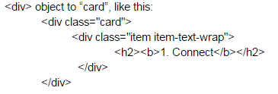  
Html tag is relatively simple so for this part I completed it within half day.

In this app there are mainly 4 functions. So there are 4 buttons to call these 4 functions. When the user pressed the ‘connect’ button, the app will first check if the Bluetooth function of the phone has been enabled, if no, the app will tell the user. If yes, the app will try to connect the Bluetooth module. If fault happens, the app will tell the user that the Bluetooth cannot be connected, the user can then check the hardware connection to find out the fault cause. To implement this function, we can simply call the functions in the Bluetooth plugin library to accomplish. When the “Connect” button is pressed, the isEnabled() function will be called to check if the Bluetooth function is enabled on the phone. If not, the content of index.html will be changed to tell the result. If yes, the connect() function will be called to start the connection. When connect() is called, the MAC address of the Bluetooth device, i.e. the Bluetooth module, has to be specified. To get the MAC address, we can connect the module with the phone first and read the address on the phone. The content of index.html will be changed to tell the result.

Other 3 buttons are ‘Start’, ‘Pause’ and ‘Reset’, which are for initializing the the reception of heartbeat rate information, pausing the reception of information and resetting the measurement and the MCU.

**Problem and Solution**

The first problem is I am not familiar to write app as I never write app before. Also, the tools needed to be used are all new to me. So I used few days to learn this new thing and ask some experienced app-developer. Luckily at last I can finish this app.

The second problem is that there are many Bluetooth plugin that can be used online. I do not know which is the best for this app. To solve this problem can only by test the Bluetooth plugin one by one and adopt the most suitable one.

**Conclusion**

This project help me to learn the latest technology and apply it practically. Although it is hard for me to write this app, I feel fulfilling and satisfying after finished the app.

Apart from technical skills learnt, we also know that the process of manufacturing a product. Now I know that doing market research is a very important step. I think it is a common fault that engineering students are always only focus on technical part.

Finally, I would like to thanks all my groupmates. They are all very helpful and work closely with each other. The project is divided into different parts but I never feel I am working alone. When I have any problems, they are willing to find out the solution with me together.

**Individual report on EIE Innovative Project 2015**

Project Title: Rider Health Condition Monitoring

Student Name: YANG Tianyu, Simon

Student No: 13102841D

Project Group: 15N15

Introduction

Our project is to make a health condition monitoring for rider to realize real time monitoring when the athlete is doing sports. In this project, we need to design the circuit and layout by ourselves. Besides, we also need to design all parts of the products from zero. I think this project is a period of good experience for me to have the first-hand experience to make electronic products.

To finish this project, we firstly search a lot of information on the Internet about some similar heartbeat sensor in order to acknowledge how this kind of electronic product works. At start, we are confused about how to use appropriate facilities and software. We thought it is quite difficult for us to finish this work. However, our teacher and tutors help us a lot to face the challenge. Then we start to divide our work into two parts, software and hardware. Our IC teacher give us a lot of suggestions and teach us how to use the PADS software and PCB layout design.

In this project, we learned a lot about PCB design and layout. During one month, we finally finished our work and make the rider health condition monitor and learned how to use an effective way to measure heartbeat.

Project role and contribution

In our group, each member has their own responsibility for this project. We divided into two groups in general. One is to do the job related to software. The other one is to do the job related to hardware. I am in hardware group and my role in this group is to design PCB circuit and layout. Besides, I will also help to make PCB and do the testing. I learned how to use software of PCB LOGIC and PCB LAYOUT to make good and rational circuit for our product. In this project, we are going to learn how to use some useful software to design PCB layout by our own.

During the period of making our product, I also try to help my teammates because we are a unite team. Because of our cooperation, we can deal with all difficulties together and solve them quickly.

Technical content and problem solving

1. **Learn know to use the sensor by oscilloscope**

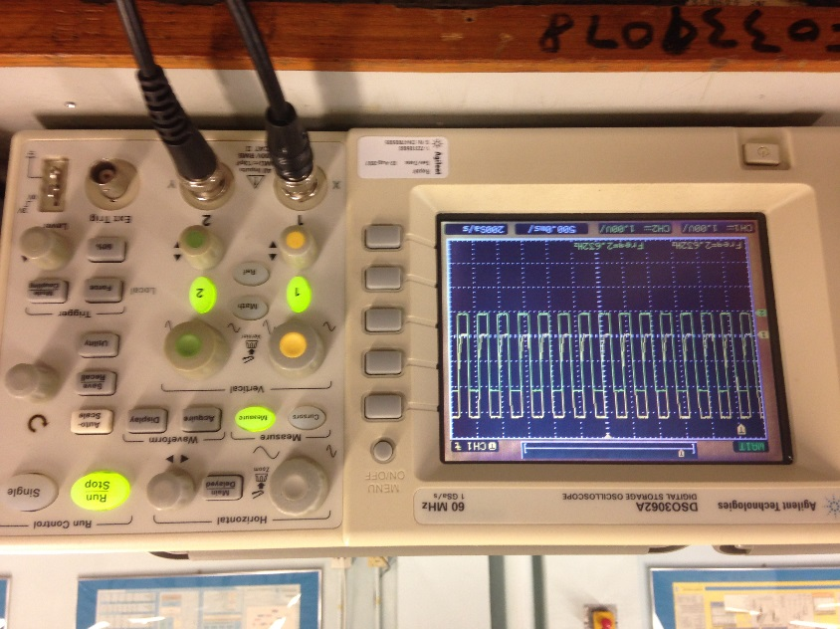When we firstly get the task of making the health condition monitor, we try to find an appropriate sensor to get heartbeat signal. The heart rate sensor has six pins. Then we use the oscilloscope to get two signals. One is analog signal, the other one is digital signal. We judge two signals and finally we decided to use the digital one because the digital signal is more concrete and clear.

Then we connect all the electrical wires to the heart rate sensor including DC input and digital output. We try to find a proper situation to locate the sensor. We find that the person is painful when the sensor touch the skin directly. Then we adjust the sensor’s situation and put it on the neck because people will feel less painful for that situation.

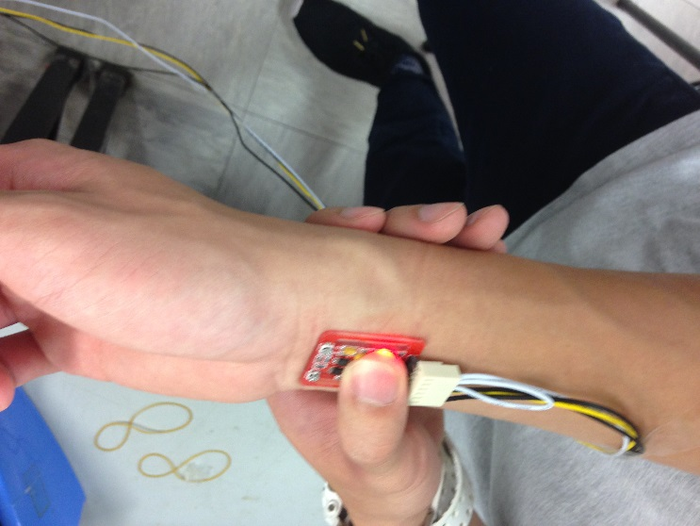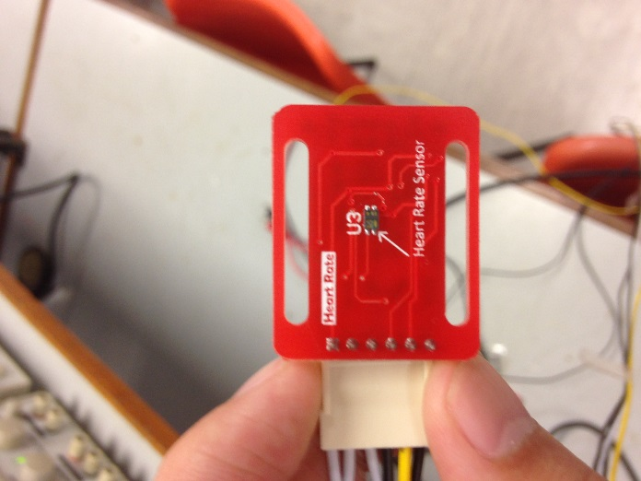

1. **Create library for components**

The next job is to create library for all the components. Our tutors teach me how to use PADS logic and PADS layout. I create all the components in this product in a new library in PADS logic and create decades for them in PADS layout.

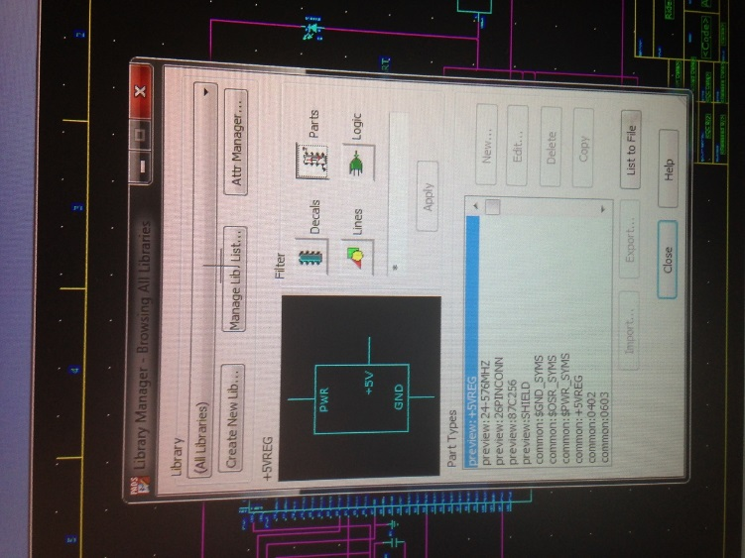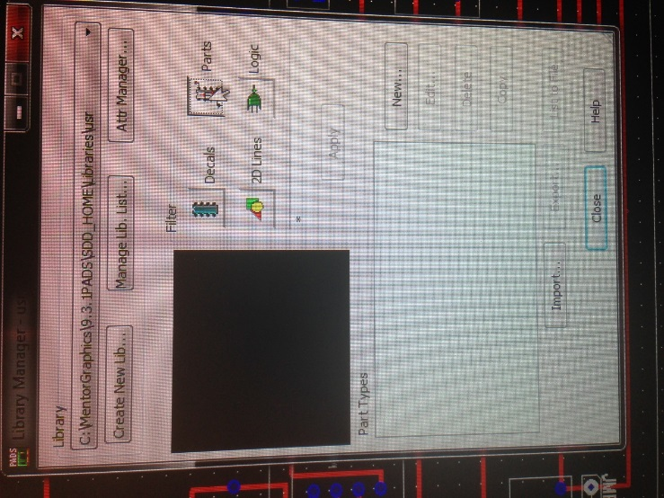

I need to create a new part in my new library and use 2D-line to create the appearance of the components. Then, I need to add new pins and edit the information of new pins so that other user will acknowledge the usage of the pins. Then I connect all the components based on the result of experiment from the software part.

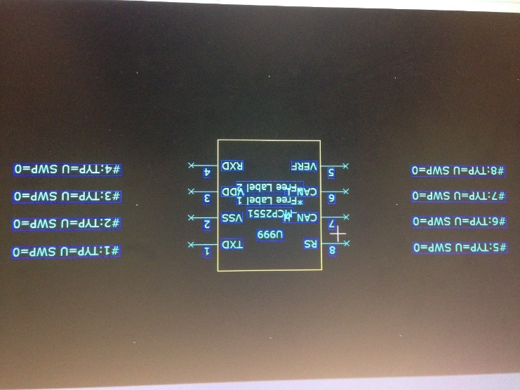

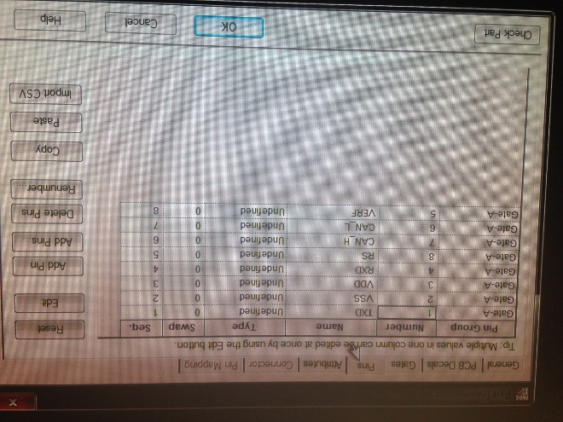

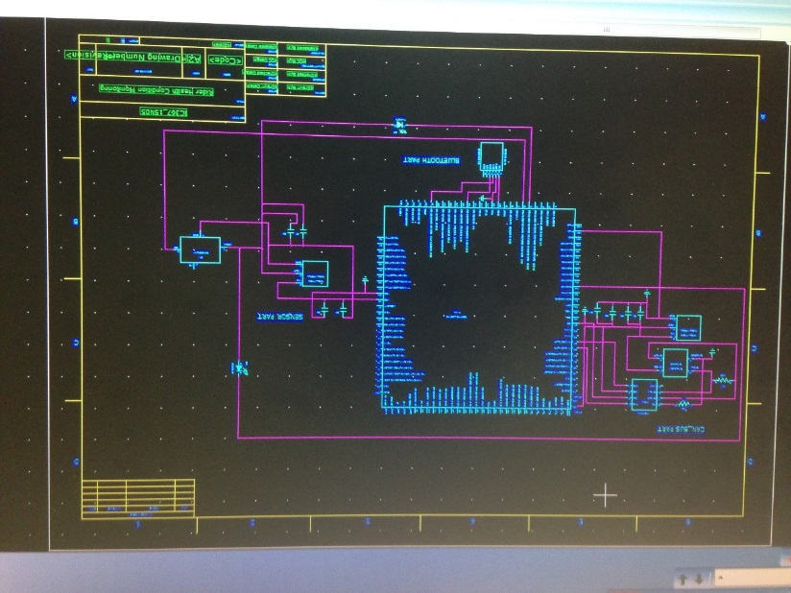

1. **Build the PCB layout and Routing**

The next step is to build PCB layout by using the software PADS Layout. I first transfer the circuit from the Logic to the Layout. Based on the decades of the components, I tried to change the electrical wires on the screen and place them at the suitable place. One of the problem we faced is that we do not know the actual size of the components. Therefore, we asked our tutor for help and borrow a electrical measurement to measure the size of the components. Besides, we also search the Internet for some parts such as the controlling board and the transformer. After all the preparing work, we finally finished the routing work and after checking all parts to make sure the layout is right, we got the PCB layout of the health condition monitoring.

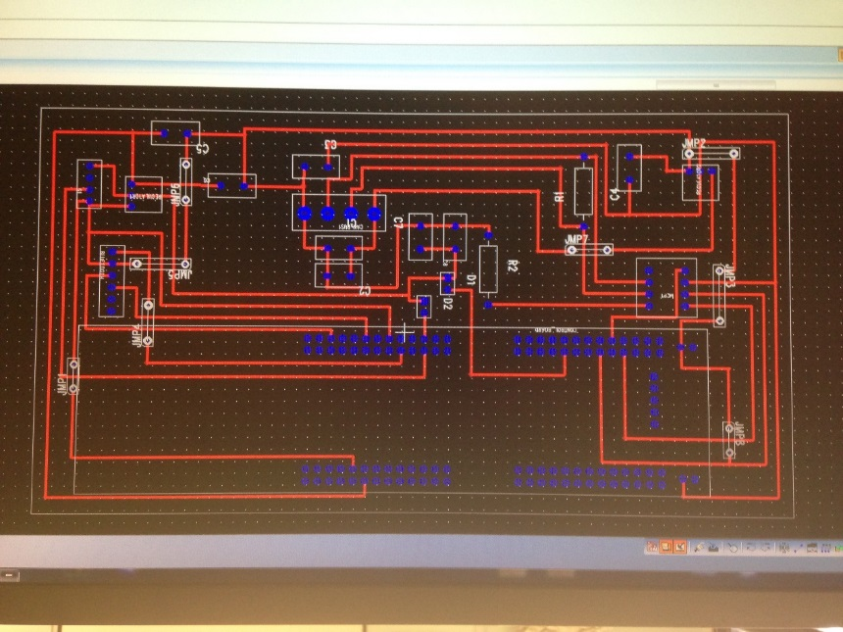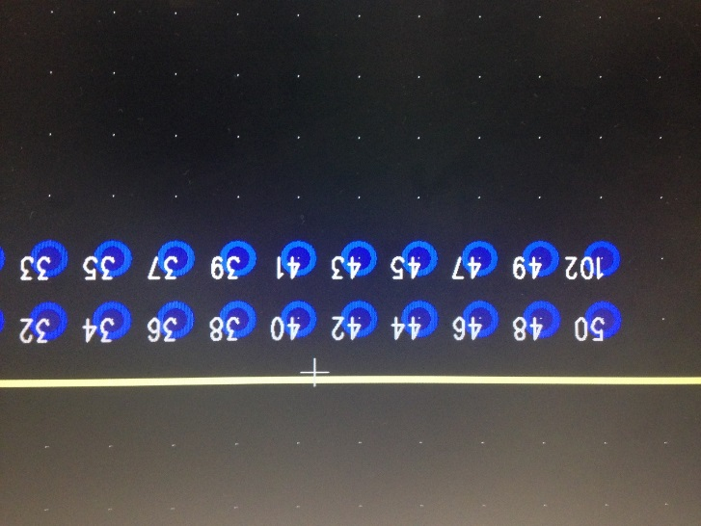

1. **Print the PCB board and complete the project**

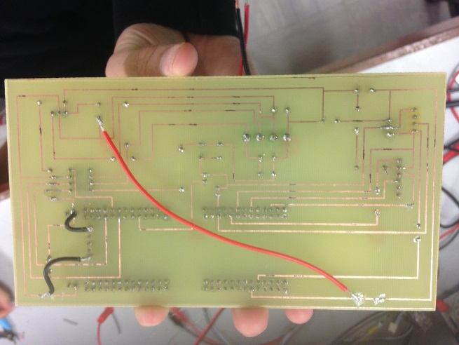After getting the layout, we used a software named “LABVIEW” and a printer to print a white on black plastic paper. Then we make the PCB board and connect all the resistors and capacitances to the board and finally we complete the task and get the health condition monitoring.

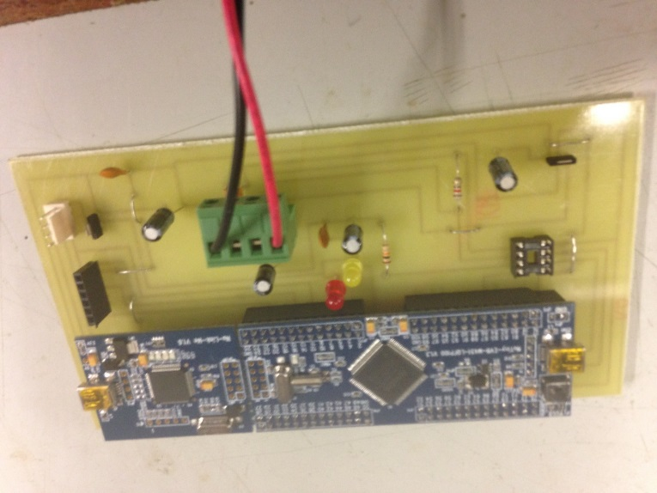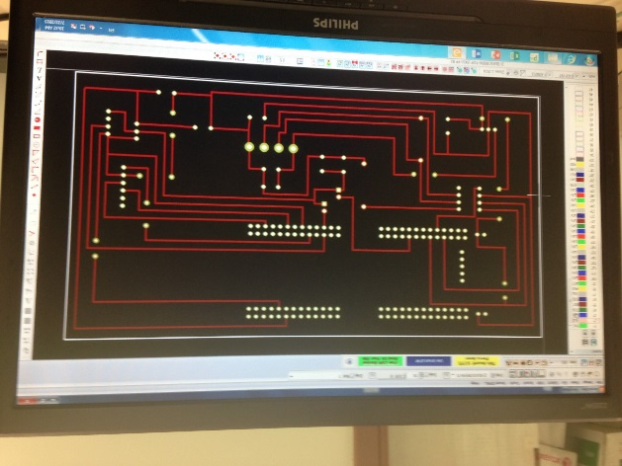

Conclusion

The project is a good experience for me to learn how to make an electrical product by our own. We learned a lot about some PCB board design. I was really pleased that I can join this group and finish a project together with other EIE students. At first, I was not familiar with this work. Later on, I know that this project is not only teaching us skills for making electronic project, but also helping us to know the communicating skills. No one can finish the whole project by himself. So long as all of our team members cooperate with each other, no matter what difficulties we faced, we will finally complete this work.

Recommendation

Although we finish our project in time, we still have a lot to improve for our project. For example, at present, we have already realized that the machine can transform the digital signal into the controlling board and we can get the heartbeat by Bluetooth. If we have enough time, we will try to use these data to calculate the calorie or other health indicator for rider. Besides, we will also try to adjust the situation for the sensor so that the rider will be more comfortable and the sensor will not disturb rider’s riding. We are still trying to make our product more perfect. We try to make the PCB board smaller so that this product can be easily carried.

Individual report

Group no: 15N05

Student name: Yip Ka Yan

Student ID: 12061354d

**Introduction**

This project is about making a condition monitoring system to detect the heartbeat rate of a pedal car rider. The sensor is used to detect the pulse of the rider and send it to the controller board to process. The processed information of heartbeat rate is then sent to either an on-board telemetry system through can bus or an android application by bluetooth. It is achieved by different program. The information is then further used in analysis for monitoring the health condition of the rider.

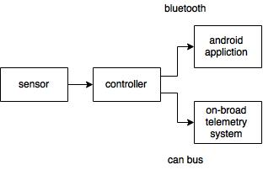

**Project Role**

In this project, I am one of the software engineer. I am responsible for the programming of the MCU and its communication with the android application. MCU and mobile application is connected through bluetooth. It is written in C language by using CooCox CoIDE.

In the program, the controller will send the processed heartbeat information to the Bluetooth transceiver through UART port. The Bluetooth transceiver between the one connected with the controller and the one built in Android phone will communicate and transfer data between each other. The heartbeat is therefore retrieved by the Android app and displayed on the app.

On the other hand, the Android application can send reset command to the UART port of the controller through the two Bluetooth transceivers. The controller, after verifying the command, will reset itself.

**Contribution**

For the MCU to communicate with HC-05, which is the bluetooth transceiver, by the UART function. The receive pin of HC-05 will be connected to the UART transmit pin of the MCU, while the transmit pin of HC-05 will be connected to the UART receive pin of the MCU.

The MCU need to communicate with UART and CAN peripherals. UART is used to communicate with the Bluetooth module.

To transmit data using UART, the UART is enabled. Then open UART port and set the correct baud rate. As the default baud rate of the Bluetooth module is 9600baud, the baud rate of the UART port is also set at 9600baud.

To receive data from the Bluetooth module, the read interrupt has to be enabled. In the interrupt handler of the read interrupt, the data received will be verified. If the data received is a character “r”, then the MCU will reset itself.

**Problem and Solution**

The can bus and bluetooth application is divided in two different program. Its because the complexity will be much more higher if these 2 modes are combined. It might easily crash each other if both are used in a single program.

Communication between teammate is important. As the bluetooth function needs to work with the android application. We need to work with each other to ensure the program work well with each other.

**Conclusion**

This is a very innovative project that help me to revise and practice what i learned in the industrial training before. Through the hands-on exercises, it helped me to get more familiar with the skills. PCB making, casing and finishing, software programming, we have to apply the knowledge we learnt from lessons. It is a precious chance to review and practice.

The problem solving skill is also trained. We have to face different problems in the process. We learnt how to trace the problem step by step and figure out the problem.

This project also helped me to develop practical skills and marketing sense in developing a product. Not only functions of the device is important but also the comfort of user, the fashion design of the device, the cost of the product, etc. There are lots of different factors are needed to be considered to make a profit making product.

Beside the technical skill, collaboration between teammates is another important thing I learnt. Communication is the key element in a team work. The project is divided into different parts and all of us are responsible for different things.But combining all our work and contribution the health monitoring system works. We have to co operate with each other.